**Ash Creek Water Control District**

Board Meeting – **September 4, 2025**

Board meeting **begins at 6:30 PM**

The meeting will be an in-person event held at Indy Commons.

Zoom will also be available: https://us06web.zoom.us/j/82158510794

1. Call to Order
2. Roll Call

⬜ Brooke Getty

⬜ Madeline Fisher

⬜ Tom Wilson

⬜ Molly Barbano

⬜ Lauren Vatkos

⬜ Ed Matteo

⬜ Todd Whitaker

⬜ Emmanuel Goicochea

⬜ Amy Albrich

⬜ Lauren Vatkos

⬜ Guests?

⬜ (Marilyn Morton, recording)

1. Online Presentation by SDAO on Strategic Planning
2. Approval of Minutes – August 7, 2025 (minutes attached)
3. Zoom presentation from SDAO on Long Range Planning and Policies
4. Treasurer’s Report
5. Audience Comments
6. Director Comments
7. Reports

* Finance: Monthly Report
* Phone: Monthly Report
* Nutria: Monthly Report
* Precipitation: Monthly Report
* Engineer’s Report
* Education Grants
* Policies & Procedures manual

1. Unfinished Business

* Educational grants outside of school district
* Bank account/LGIP signers/authorizations complete?
* Any Update on formation of Regional Mid-Willamette West Waterway Partnership

1. New Business, Miscellaneous Business/Information Items

* Correspondence
* Updating/Reviewing Policies and Procedures Manual
* Establishing a Strategic Planning schedule

12. Adjournment & next meeting

**Documents following include:**

Minutes from August meeting

Financial recap of latest information available from institutions.

Board of Directors, Positions & Terms

Links for communications from SDAO

MOA for future use

Ash Creek Water Control District Minutes, 8-7-25, 6:30 PM, Indy Commons

1. Treasurer Tom Wilson called the meeting to order at 6:30 PM
2. Roll Call: Brooke Getty, Madeline Fisher, Tom Wilson, Molly Barbano, Ed Matteo, Todd Whitaker (7 PM arrival), Amy Albrich, Marilyn Morton.  ABSENT: Lauren Vatkos, Emanual Goicochea

Tom Wilson noted that a letter was received from the election department of Polk County to say that Lauren Vatkos’ documentation did not arrive in time to certify the election. Therefore, Tom Wilson moved to appoint Lauren Vatkos as Director 7, Brooke Getty 2nd, motion passed 6-0. This appointment is effective until the next election (2027).

1. Election of Officers

Ed Matteo moved to elect Tom Wilson as both Chairman and Treasurer. Tom’s election as treasurer will be effective through June 30, 2026. Madeline Fisher 2nd, motion passed 6-0. Tom Wilson is the new Chair and continues to as Treasurer of ACWCD.

Tom Wilson moved to elect Ed Matto as Co-Chair, Brooke Getty 2nd, motion passed 6-0. Ed Matto is the new Co-Chair of ACWCD.

1. Minutes of 7-10-25 meeting: Amy Albrich moved to approve the minutes as presented, Tom Wilson 2nd, motion passed 6-0.
2. Swearing in of all new board members, including Lauren Vatkos, has been done.
3. Audience comments – none
4. Director comments:
5. Reports
6. Treasurer’s report – a full report will be presented at the next meeting. Current balance at LGIP is $463,749.22. One bill from Rome Forrester for $7,306.41, and has been paid. The Extension Service is collecting ash seeds. A copy of their flyer is attached to these minutes.
7. Madeline reported coyote and deer have been observed. So far no Emerald Ash Borers have been caught in any of the traps.
8. Tom has scheduled a 20 minute presentation on zoom with SDAO to discuss strategic planning
9. Phone: Ed reported there was one message about water rights but call backs went unanswered
10. Nutria: no nutria trapped. Anne Scheck did a nice article in her publication about Ed, Nutria Trapper.
11. Precipitation:

July 2025 = 0"

July 2024 = .09"

July 2023 = .01"

July 2022 = .14"

July 2021 = 0"

1. Engineer’s Report: None
2. Education Grants:

The two grants submitted and approved were paid. Brooke and Molly have communicated with grant recipients, secured signed contracts. Reports will be coming from:

* Dave Beatley -Talmadge Middle - Life Along Ash Creek (a stop motion story) - $1000 grant
* Emily Blythe – (elementary 5th grade team): Bio-Diversity In Bottle - $835 grant

1. Policies & Procedures manual: A copy will be available at the next meeting
2. Unfinished Business

* Bank account/LGIP signers/authorizations: All board members are or will be signers on the account. Tom will secure documentation and asked that copies of signers’ SSN and ODL be delivered to Pioneer Bank if not already in their possession. Signature cards will be executed at the September meeting.

1. Correspondence – none additional to what was in agenda packet
2. Additional discussion: about serial communications (prohibited for boards to engage in them). There is a training available on September 24 at Chemeketa Viticulture Center in West Salem if anyone is interested.
3. Adjournment & next meeting

* Ed Matteo moved to adjourn the meeting, Brooke Getty 2nd, motion passed 7-0. Meeting was adjourned at 8 PM.
* Next Meeting September 4 at Indy Commons @ 6:30 PM.
* At the next meeting there will be a 20 minute virtual presentation by SDAO on Strategic Planning.

Checking Account recap:

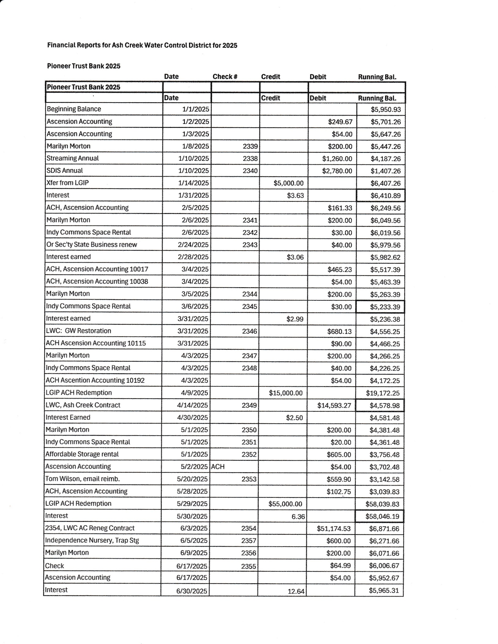

**Statements from Accountant include:**

Statement of Activity, July 1, 2024 to June 30, 2025

Statement of Activity (month to month), July 1, 2024 to June 30, 2025

Statement of Financial Position as of June 30, 2025

Statement of Activity, April 1 to June 30, 2025

Statement of Activity, April to June, 2025

Transaction Detail by Account, April-June 2025 (2 pages)

**WITH ELECTION RESULTS:**

**Board of Directors, Positions & Terms after May 20 election**

Mailing Address & Phone Number for all Directors:

PO Box 81, Independence, OR 97351, 503 779-9869

**Director #1**

Tom Wilson

Term: 2027

Email: director1@ashcreekwcd.com

**Director #2**

Emmanuel Goicochea

Term expires: 2027

Email: director2@ashcreekwcd.com

**Director #3**

Madeline Fisher

Term expires: 2029

Email: director3@ashcreekwcd.com

**Director #4**

Molly Barbano

Term expires: 2028

Email: director4@ashcreekwcd.com

**Director #5**

Brooke Getty

Term expires: 2028

Email: director5@ashcreekwcd.com

**Director #6**

Ed Matteo

Term expires: 2027

Email: director6@ashcreekwcd.com

**Director #7**

**Lauren Vatkos**

Term expires: 2029

Email: director7@ashcreekwcd.com

**Director #8:**

Amy Albrich

Term expires: 2027

Email:

Director8@ashcreekwcd.com

**Director #9**

**Position remains vacant**

*Term expires: 2029*

Email: director9@ashcreekwcd.com

**Content/Links for electronic correspondence:**

**From SDAO:**

<https://www.magnetmail.net/actions/email_web_version.cfm?ep=aiG7TXw8p6eAbFY-OXtJeeh-YEJi5KifS4hIjg748XrXUojMrC5jkHsOjOgw-6A3upWBAFvROTWLcDxQLD1G1luVKXwKbI7JHeuEP2HfEVhWtbDhfp-yNuBkVwsncJjV>

<https://www.magnetmail.net/actions/email_web_version.cfm?ep=aiG7TXw8p6eAbFY-OXtJeeh-YEJi5KifS4hIjg748XrNGWTXAO6Guf889Uu1P2KXFi-nGnRheZRx-AGCsRBXVOL9lOdd8W8bitWXt-GH3Ku4uKDbEVZHaBpjL-jI7h4P>

<https://www.magnetmail.net/actions/email_web_version.cfm?ep=aiG7TXw8p6eAbFY-OXtJeeh-YEJi5KifS4hIjg748XrebU8Yfqog92TM8c0MTOUncqcbK50EwOfMVPsguYTaCl3sAhJvxoZSI15eZJQmGdK3m8NDUY4N6TR_rbNDmEFe>

<https://www.magnetmail.net/actions/email_web_version.cfm?ep=aiG7TXw8p6eAbFY-OXtJeeh-YEJi5KifS4hIjg748XpHBcfOvg3eYsJnYM_ivwVRP5cxR8GD8lObMdHOQmljGfLNx-ffr1RPP6nHOZWPBaQZKU7NijbMnSUq8ey_x07u>

<https://www.magnetmail.net/actions/email_web_version.cfm?ep=aiG7TXw8p6eAbFY-OXtJeeh-YEJi5KifS4hIjg748XrmX3ikuvL6ZMVmu4TzxUkDHEVSlr_9ab0im8GX1uu6hmlMsDnuTetRAGAuuoEqdyGepGmsJV_6A6RPyYHZBpXF>

**----- D R A F T -----**

**MEMORANDUM OF UNDERSTANDING**

**Mid-Willamette West Waterway Partnership (GROUP NAME???)**

**(Regional Collaboration for Preservation and Protection of Watershed Health)**

Mission: To provide useful information to residents of the region’s community members that demonstrates the importance of protecting local waterways for the beneficial uses of all residents. The partners of the [Name of the group] believe that clean, healthy streams help support thriving, healthy communities. Watershed health is achieved by the actions and behaviors of an engaged population. We will work together to create a positive, impactful experience that will drive environmentally sound practices within our communities.

Goal: The goal of this collaborative effort is to demonstrate that a unified regional voice can effectively share environmental messaging, reaching a broader audience than individual efforts alone. The [Name of the group] will focus on sharing resources to develop and promote public events that educate community members about local water resources and how to protect them. Resources may include such as: staff time, tools, equipment, technical expertise, participation, funding, or other support.

Partners: Local governments, watershed councils, and special districts are encouraged to join this collaborative effort to help build strong, lasting relationships. Together, we share a commitment to improving watershed health and protecting the regional environment. This project aims to Increase public awareness and community involvement in local waterway stewardship efforts.

Participation Expectations: Partners are invited to contribute resources, offer feedback, and support project initiatives as appropriate. The group will collaborate to establish a mutually agreeable schedule and determine how each partner can best contribute to the overall success of the projects.

Core Event: The [Name of the group] will organize and host at least 1 public core event annually that will serve as a focal point for the group’s efforts. The intent of the event will be to promote an aspect of watershed health that is of benefit to the audience. The objective is to establish a recognizable event that will draw new and established participation from year to year. The group may also develop other related events or provide support for existing established events that support regional watershed health education.

Logos and Permissions: An electronic version of each organization’s logo should be included in any shared project materials, and on any approved promotional material for individual websites. Shared logos help to promote the collective efforts and activities of all participating groups.

Duration: *Ongoing until amended by the group*.

Signatures: