Ash Creek Water Control District
Board Meeting – October 2, 2025
Board meeting begins at 6:30 PM
The meeting will be an in-person event held at Indy Commons.
Zoom will also be available: https://us06web.zoom.us/j/82158510794
- Call to Order
- Roll Call

Brooke Getty
Madeline Fisher
Tom Wilson
Molly Barbano
Lauren Zatkos
Ed Matteo
Todd Whitaker
Amy Albrich
Guests?
(Marilyn Morton, recording)
- Approval of Minutes – September 4, 2025
- Minutes of September meeting (attached)
- Audience Comments
- Director Comments
- Reports
- Finance: Monthly Report
- Phone: Monthly Report
- Nutria: Monthly Report
- Precipitation: Monthly Report
- Engineer’s Report
- Education Grants
- Unfinished Business
- Review of 10 year plan: time for discussion. Access the 10 year plan by visiting: file:///C:/Users/maril/Downloads/ACWCD%2010%20Yr%20Plan%20-%20Final%20(1).pdf
- Consideration of educational grants outside of school district
- Bank account/LGIP signers/authorizations complete?
- Is registration with Secretary of State required by bank?
- Updating Policies & Procedures Manual (a significant amount of time should be dedicated to this activity during the meeting). Work Document attached.
- Any Update on formation of Regional Mid-Willamette West Waterway Partnership
- New Business, Miscellaneous Business/Information Items
- Correspondence
- Establishing a Strategic Planning schedule
- New ADA web requirements for PDF accessibility discussion (copy attached)
10. Adjournment & next meeting

Note for November meeting of ACWCD: Russell Cooper & Mark Landau, Monmouth Public Works, will be attending the November meeting. We are still waiting to hear if Gerald Fisher from Independence will be available. Following is an email from the ACWCD chair to both cities’ Public Works departments.
Hello Russ and Gerald,
My name is Tom Wilson and I am the new chair of the Ash Creek Water Control District. We are starting the process of developing a 10 year strategic plan (see attached current plan for reference).
The board feels it would be a good time to sit down with our community partners and see what our small tax base can do to help with drainage/flooding/tmdl with in our district. We have had turn over on the board and have some great new people who are embracing the work. I know we have worked successfully together in the past but we have lost alot of institutional knowledge lately. May be you could provide them a recap of past projects? Suggest other projects that the board might support?
I made this help illustrate our boundries.
https://rhythm.maps.arcgis.com/apps/mapviewer/index.html?webmap=2476b9767e9f4f33b00f8b791fcc76b5
I am inviting you (or someone from your dept) to attend any of the upcoming board meetings (First Thursday of the Month, 6:30 PM @ Indy Commons) on Oct 2, Nov 6, and Dec 4.
Please RSVP to Marilyn at distsec@ashcreek.com and we will put you on the Agenda. Thanks!

Documents following include:
Minutes from October meeting

Financial recap of latest information available from institutions.

Board of Directors, Positions & Terms

Links for communications from SDAO

Ash Creek Water Control District Minutes, 10-2-25, 6:30 PM, Indy Commons
- Treasurer Tom Wilson called the meeting to order at 6:35 PM
- Roll Call: Brooke Getty, Tom Wilson, Molly Barbano, Ed Matteo, Amy Albrich (online), Todd Whitaker, Marilyn Morton. Absent/Excused: Madeline Fisher, Lauren Zatkos. Note: Emanual Goicochea resigned.
There was not a quorum; this meeting will be Informational Only.
- Minutes of 9-4-25 meeting: Deferred until a quorum is present.
- Audience comments – none
- Director comments:
- Reports
- Tom Wilson gave an informational Treasurer’s/Financial report. Prepaid Visa card will be discussed at the next meeting.
- Phone: Brooke Getty reported there were no calls.
- Nutria: Ed Matteo’s report – 1 nutria caught in Old Town, 2 caught south of Independence (total 3 caught). 53 traps remain out.
- Precipitation:
September 2025 = 1.48"
September 2024 = 0.86"
September 2023 = 2.84"
September 2022 = 0.47"
September 2021 = 2.62"
- Engineer’s Report: Nothing at this time. Rulings regarding FEMA/ endangered species and Draft Environmental Impact Statement discussed. Public comment is currently being accepted about the Impact Statement, which must support a policy of “no net loss of habitat”.
- Education Grants: Checks have been issued on all current grants. Brooke will file all necessary documents and send copies to Tom for posting on the website
- Unfinished Business
- Digital Storage was discussed. Tom explained the access into document storage.
- Name of ACWCD discussed; it must remain as is according to ORS553.
- Bank/LGIP signers’ signatures and information is being gathered. Should be done shortly.
- Regional Mid-Willamette West Waterway Partnership; holding for more information
- New Business
- Update/Review the Policies & Procedures Manual. Note: grants outside of the school district, as previously discussed, must be defined in the updated Policies and Procedure Manual.
- Tom presented a draft; updated manual to be presented at future meeting.
- Correspondence – From Public Works
- 10 year plan: Digital access is at file:///C:/Users/maril/Downloads/ACWCD%2010%20Yr%20Plan%20-%20Final%20(1).pdf.
- Strategic Planning Schedule: Development of plan will occur in November/December. From the completed plan the next biennial budget will be drawn.
- Planning details:
- There must be a resolution for adopting a new Strategic Plan
- The Policies & Procedures Manual must include rescission of any existing plans.
- Todd gave an outline of what a 10-year strategic plan needs to include.
- He said the last map revision was done in 2011-2012, and it focused on Inspiration Gardens.
- Map revisions must reflect current FEMA flood plan maps.
- Todd will be doing a lot of this work in the planning process.
- He suggested board members review Chapter 5 as it will become a template for planning.
- At the next meeting internal budget consideration will begin. The ACWCD’s Budget Committee begin public meetings in February.
- Tom said there are new ADA web requirements for PDF accessibility. These are the new standards for screen readers for the visually impaired. Tom reported that the ACWCD website is already updated.
- Please plan for Russ Cooper, Mark Landau (Monmouth Public Works) & hopefully Gerald Fisher (Independence Public Works) to be in attendance at the next meeting.
- Marilyn informed the board that she met with SDIC/SDAO, an annual process.
- Adjournment & next meeting
- It was moved and seconded to adjourn the meeting at 8:02 PM.
- Next Meeting November 6 at Indy Commons @ 6:30 PM.

Pioneer Trust Bank 2025
 | Date | Credit | Debit | Running Balance
Beginning Balance | 1/1/2025 |  |  | $ 5,950.93
Ascension Accounting | 1/2/2025 |  | $ 249.67 | $ 5,701.26
Ascension Accounting | 1/3/2025 |  | $ 54.00 | $ 5,647.26
2339, Marilyn Morton | 1/8/2025 |  | $ 200.00 | $ 5,447.26
2338, Streaming Annual | 1/10/2025 |  | $ 1,260.00 | $ 4,187.26
2340, SDIS Annual | 1/10/2025 |  | $ 2,780.00 | $ 1,407.26
Xfer from LGIP | 1/14/2025 | $ 5,000.00 |  | $ 6,407.26
Interest | 1/31/2025 | $ 3.63 |  | $ 6,410.89
ACH, Ascension Accounting | 2/5/2025 |  | $ 161.33 | $ 6,249.56
2341, Marilyn Morton fee | 2/6/2025 |  | $ 200.00 | $ 6,049.56
2342, Indy Commons space rental | 2/6/2025 |  | $ 30.00 | $ 6,019.56
Renew | 2/24/2025 |  | $ 40.00 | $ 5,979.56
Interest earned | 2/28/2025 | $ 3.06 |  | $ 5,982.62
ACH, Ascension Acctg 10017 | 3/4/2025 |  | $ 465.23 | $ 5,517.39
ACH, Ascension Acctg 10038 | 3/4/2025 |  | $ 54.00 | $ 5,463.39
2344, Marilyn Morton fee | 3/5/2025 |  | $ 200.00 | $ 5,263.39
2345, Indy Commons space rental | 3/6/2025 |  | $ 30.00 | $ 5,233.39
Interest earned | 3/31/2025 | $ 2.99 |  | $ 5,236.38
2346, LWC: GW Restoration | 3/31/2025 |  | $ 680.13 | $ 4,556.25
ACH Ascension Accounting 10115 | 3/31/2025 |  | $ 90.00 | $ 4,466.25
2347, Marilyn Morton fee | 4/3/2025 |  | $ 200.00 | $ 4,266.25
2348, Indy Commons (Board mtg) | 4/3/2025 |  | $ 40.00 | $ 4,226.25
ACH Ascension Accounting 10192 | 4/3/2025 |  | $ 54.00 | $ 4,172.25
2349, LWC, Ash Creek Contract | 4/8/2025 |  | $ 14,593.27 | $ (10,421.02)
LGIP ACH Redemption | 4/9/2025 | $ 15,000.00 |  | $ 4,578.98
Interest Earned | 4/30/2025 | $ 2.50 |  | $ 4,581.48
2350, Marilyn Morton fee | 5/1/2025 |  | $ 200.00 | $ 4,381.48
2351, Indy Commons space rental | 5/1/2025 |  | $ 20.00 | $ 4,361.48
2352, Affordable Storage rental | 5/1/2025 |  | $ 605.00 | $ 3,756.48
2353, Tom Wilson, email reimb. | 5/20/2025 |  | $ 559.90 | $ 3,196.58
2354, LWC AC Reneg Contract | 5/28/2025 |  | $ 51,174.53 | $ (47,977.95)
LGIP ACH Redemption | 5/31/2025 | $ 55,000.00 |  | $ 7,022.05
ACH, Ascension Accounting | 5/28/2025 |  | $ 102.75 | $ 6,919.30
2355, Tom Wilson email reimb. | 5/29/2025 |  | $ 64.99 | $ 6,854.31
2356, Marilyn Morton fee | 6/5/2025 |  | $ 200.00 | $ 6,654.31
2357, Independence Nursery Grd | 6/5/2025 |  | $ 600.00 | $ 6,054.31
Interest earned | 5/30/2025 | $ 6.36 |  | $ 6,060.67
ACH, Ascension Accounting | 6/2/2025 |  | $ 54.00 | $ 6,006.67
Ascension Accounting | 6/17/2025 |  | $ 54.00 | $ 5,952.67
Interest earned | 6/30/2025 | $ 12.64 |  | $ 5,965.31
USPS Box 81 | 7/1/2025 |  | $ 210.00 | $ 5,755.31
Polk County Clerk Election Fee | 7/1/2025 |  | $ 4,936.85 | $ 818.46
SAIF Insurance (annual) | 7/1/2025 |  | $ 306.63 | $ 511.83
CNA Surety (annual) | 7/1/2025 |  | $ 500.00 | $ 11.83
LGIP Reimbursement | 7/14/2025 | $ 10,000.00 |  | $ 10,011.83
Ascension Accounting | 7/5/2025 |  | $ 141.50 | $ 9,870.33
Ascension Accounting | 7/25/2025 |  | $ 135.00 | $ 9,735.33
Interest | 7/31/2025 | $ 5.33 |  | $ 9,740.66
Ascension Accounting | 8/1/2025 |  | $ 54.00 | $ 9,686.66
Roam Forestry, Chk 2362 | 8/7/2025 |  | $ 7,306.41 | $ 2,380.25
Marilyn Morton, Chk 2363 | 8/7/2025 |  | $ 200.00 | $ 2,180.25
LGIP Transfer | 8/7/2025 | $ 5,000.00 |  | $ 7,180.25
Ash Creek Elem. Ed. Grant #2364 | 8/7/2025 |  | $ 835.00 | $ 6,345.25
Interest | 8/25/2025 | $ 4.55 |  | $ 6,349.80
Talmadge Middle School Ed. Grant | 8/7/2025 |  | $ 1,000.00 | $ 5,349.80
Ascension Accounting (2 inv.) | 8/25/2025 |  | $ 176.90 | $ 5,172.90
LGIP Transfer | 9/1/2025 | $ 10,000.00 |  | $ 15,172.90
Marilyn Morton contract | 9/4/2025 |  | $ 200.00 | $ 14,972.90
Indy Comons meetings | 6/4/2025 |  | $ 60.00 | $ 14,912.90
LWC Reneg Contract | 9/4/2025 |  | $ 7,870.40 | $ 7,042.50

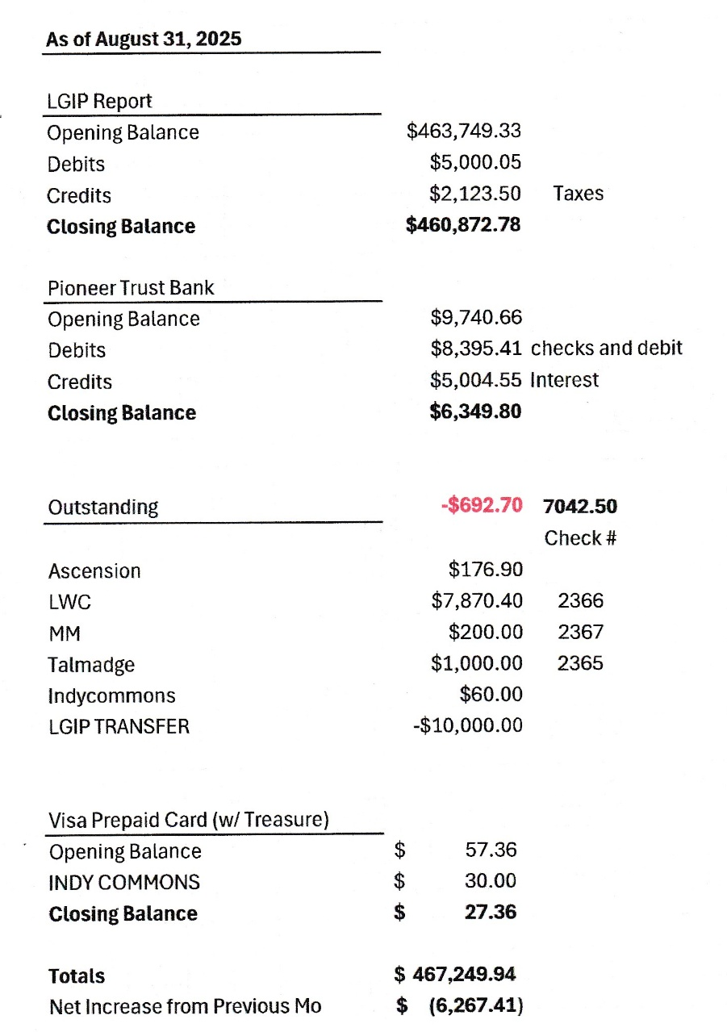

WITH ELECTION RESULTS:
Board of Directors, Positions & Terms after May 20 election

Mailing Address & Phone Number for all Directors:
PO Box 81, Independence, OR 97351, 503 779-9869

Director #1
Tom Wilson, President & Treasurer
Term: 2027
Email: director1@ashcreekwcd.com

Director #2
Vacant
Next election: 2027
Email: director2@ashcreekwcd.com

Director #3
Madeline Fisher
Term expires: 2029
Email: director3@ashcreekwcd.com

Director #4
Molly Barbano
Term expires: 2028
Email: director4@ashcreekwcd.com

Director #5
Brooke Getty
Term expires: 2028
Email: director5@ashcreekwcd.com

Director #6
Ed Matteo, Vice President
Term expires: 2027
Email: director6@ashcreekwcd.com

Director #7
Lauren Zatkos
Term expires: 2029
Email: director7@ashcreekwcd.com

Director #8:
Amy Albrich
Term expires: 2027
Email:
Director8@ashcreekwcd.com

Director #9
Position remains vacant
Term expires: 2029
Email: director9@ashcreekwcd.com

Content/Links for electronic correspondence:
From SDAO:
https://www.magnetmail.net/actions/email_web_version.cfm?ep=aiG7TXw8p6eAbFY-OXtJeeh-YEJi5KifS4hIjg748Xo4O1qeaHfgJhFNIKRcNGZheZz-tG742Z7zaPzk7evnengU_pS9Z4UsrQZoJwI6vs6OyRxfPMXbGQrSAypIBfdY
If you are interested, here is the link to the latest Legislative Report:
https://www.sdao.com/files/b7375d76e/2025+SDAO+Legislative+Session+Report.+Final+%28002%29.pdf?utm_source=MagnetMail&utm_medium=email&utm_term=distsec%40ashcreekwcd%2Ecom&utm_content=251003%20Legislative%20Session%20Report&utm_campaign=2025%20Legislative%20Session%20Report

https://www.magnetmail.net/actions/email_web_version.cfm?ep=aiG7TXw8p6eAbFY-OXtJeeh-YEJi5KifS4hIjg748XoL69AW-GQ-jRXmvajHVJf5NemyiStROWyUS6ksvbpweZ0UWwKXVX12cHYZvlzcpvc2tcmhi2HD6tUNqJ_wDcW6

https://www.magnetmail.net/actions/email_web_version.cfm?ep=aiG7TXw8p6eAbFY-OXtJeeh-YEJi5KifS4hIjg748XqWQ3WRYHOCjNUcnedQBvjLHOQ52M4xd1JSDIb5e0O9Uw4POpr7gl51CR7iskdVyDUJCgvf8WVmpHq9gfRItn4d

https://www.magnetmail.net/actions/email_web_version.cfm?ep=aiG7TXw8p6eAbFY-OXtJeeh-YEJi5KifS4hIjg748XqIUCRbdccHTy-K3an4PNzu-H1Kz2nAiNxFRdpad3PMvTF2wJKq2zwDc_PoTWHnZ2iggPrVg4AHKcCvZQ6jIWJr
https://www.magnetmail.net/actions/email_web_version.cfm?ep=aiG7TXw8p6eAbFY-OXtJeeh-YEJi5KifS4hIjg748XpuxqwxUFIWpSKfGlKPaKIwUK4afiLvP28XpyjADvPwc6Cn-Tno9VcFAatzVm70qNczqIwpn59WSzrkKrNjj7vO
SDAO/SDIS Insurance – updated and modified aspects can be found at:
Sexual Misconduct: file:///C:/Users/maril/Downloads/Sexual%20Misconduct%20Coverage%20(1).pdf
Cyber Coverage Application:
file:///C:/Users/maril/Downloads/Cyber%20Coverage%20(1).pdf

