Ash Creek Water Control District, AGENDA
Board Meeting – May 7, 2026
Board meeting begins at 6:30 PM
This is an in-person meeting at Indy Commons. To join by Zoom, please use this link:
https://us06web.zoom.us/j/82158510794?pwd=zBEajDFo31FeaehdbuRWLOkQoafd5S.1
- Call to Order
- Roll Call

Brooke Getty
Madeline Fisher
Tom Wilson
Molly Barbano
Lauren Zatkos
Ed Matteo
Todd Whitaker
Amy Albrich
Guests?
(Marilyn Morton, recording)

- Minutes of April meeting (attached)
- Update on Certificate of insurance for Storage Unit (storage unit is not mentioned in policy from WHA)
- Audience Comments
- Director Comments
- Reports
- Finance: Monthly Report
- Phone: Monthly Report – continue buying minutes or investigate other options?
- Nutria: Monthly Report
- Precipitation: Monthly Report
- Engineer’s Report
- Education Grants
- Unfinished Business
Continue Biennium Budget Work: Update on budget committee makeup. First meeting is May 4. This meeting has been noticed in the Itemizer-Observer.
Report on Luckiamute Watershed Council Spring Social, April 11?
- New Business
Consideration of new board member(s)?
- Adjournment & next meeting: Budget Meeting 5-14-2026, June meeting 6-4-2026

Documents following include:
Minutes from April meeting

Budget Calendar for 2026-2028 biennium

Copy of 2024-2026 Budget

Financial recap of latest information available from institutions.

Board of Directors, Positions & Terms

Links for communications from SDAO & others

Oath of office, if needed

Ash Creek Water Control District, Minutes
Meeting was held at Indy Commons with a Zoom option.
- Call to Order by Chair Tom Wilson at 6:32 PM
- Roll Call. In attendance Brooke Getty (online), Madeline Fisher, Tom Wilson, Molly Barbano, Ed Matteo, Todd Whitaker Amy Albrich. Marilyn Morton recording. Not present: Lauren Zatkos.
- Minutes of March meeting: Amy moved to approve the minutes, seconded by Madeline. Motion passed unanimously.
- The ACWCD storage unit is requiring insurance coverage for the contents, or the rates will be raised from $55/month to $70/month. Tom is working with WHA (insurance company) and storage facility to resolve this.
- Audience Comments - None

- Director Comments
- Reports
- Finance: Monthly Report – Tom gave the financial report for the 3rd quarter of the 2025-2026 FY. ACWCD is doing well financially.
- Garbage Can Signage – Ed showed one of the new signs and one that is being retired. He has or will replace all that need to be done.
- Phone: Monthly Report – phone ran out of minutes. Discussion about options. It was decided to purchase more minutes for the phone, take up this discussion again at the next meeting.
- Nutria: Monthly Report – 3 nutria were trapped; 2 traps are deployed in the community
- Precipitation: Monthly Report – Madeline first reported that Polk SWCD is doing temperature monitoring. The precipitation report:
2021, 2.02:
2022, 5.14”
2023, 4.33”
2024, 5.18:
2025, 7.41”
2026, 3.13”
- Engineer’s Report – No report
- Education Grants – No report
- Lauren needs help with e-mail access. Tom will manage that.
- Unfinished Business
Continued Biennium Budget Work. Figures were reviewed. Board was asked to bring budget ideas to the May meeting.
Strategic Plan is ready to go to Todd. The vote on the finished document is to come after Todd presents a final draft at the May meeting. Discussion continued on aspects of the Strategic Plan.
Budget Calendar: The calendar was reviewed. Dates and plans were refined. Ed moved to approve the budget calendar as discussed, Madeline 2nd, motion passed unanimously. The final approved version is attached to these minutes.
Tom attended the Storm Water Master Plan Open House held in Independence. It was “non-informational”.
- New Business
Molly and Madeline are planning to attend Luckiamute Watershed Council Spring Social, April 11.
Consideration of new board member? Deferred to next meeting.
- Adjourn. Meeting adjourned at 7:36 PM. Next meeting May 7, 2026, 6:30 PM, Indy Commons.

ASH CREEK WATER CONTROL DISTRICT

BUDGET CALENDAR
FY 2026-28, Adopted by BOD 4-2-26

1. Budget Officer Appointed March 5, 2026

2. Proposed Budget Prepared March/April, 2026

3. Budget Officer Publishes Notice (2x) May 6 & May 13, 2026
'Notice of Budget Committee Meeting'

4. Budget Committee Meets, 6:30 p.m. May 14, 2026, 6:30 PM, Indy Commons
-Additional meetings as needed

5. Budget Committee Approves Budget No later than mid-May 2026

6. Notice Published Between May 15 and June 4
'Budget Summary and Notice of (due to I-O noon, 5/16)
Budget Hearing'

7. Budget Hearing Held June 4, 2026 (regular mtg date)
Budget Adopted, Appropriations Made, (Budget must be adopted NLT
Taxes Imposed & Categorized 6/30)

8. Taxes Certified to County Assessor No later than July 15, 2026

9. Copy of Budget to County Clerk No later than Sept. 30, 2026

Notes about Budget Message
The Budget Officer (District Secretary) publishes the Budget Message along with a copy of the 2026-2028 biennium budget to the Budget Committee that is scheduled to meet on May 14.

Updates to the budget message (which is in part a historical recitation of the founding/purpose of ACWCD) must include these new 2026-2028 Biennium Budget figures:
(The following are subject to updates)

10-Year plan:
- Knowledge Based $ _____________ (was $7,500 in 2022-2024)
- Physical/Dedicated $_______________ (was $193,500 in 2022-2024)
- Physical/Other $__________________ (was $7,500 in 2022-2024)

Projects – Other $_________________ (was $10,500 in 2022-2024)
- Education Grants $_________________ (was $5,000 in 2022-2024)
- Outreach $_________________ (was $2,000 in 2022-2024)
- Garbage Cans $_________________ (was $1,300 in 2022-2024)
- Nutria $_________________ (was $1,200 in 2022-2024)
- Spray $_________________ (was $1,000 in 2022-2024)

APPROVED BUDGT from 2024-2026 Biennium, for reference
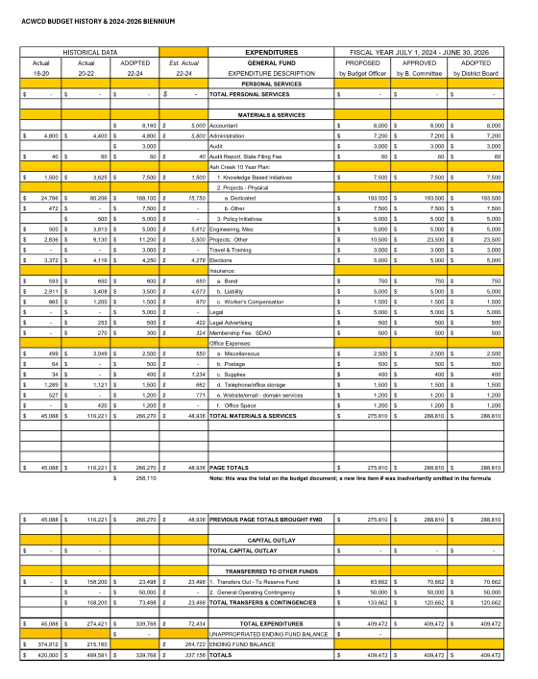
Board of Directors, Positions & Terms after May 20 election

Mailing Address & Phone Number for all Directors:
PO Box 81, Independence, OR 97351, 503 779-9869

Director #1
Tom Wilson, President & Treasurer
Term: 2027
Email: director1@ashcreekwcd.com

Director #2
Next election: 2027
Email: director2@ashcreekwcd.com

Director #3
Madeline Fisher
Term expires: 2029
Email: director3@ashcreekwcd.com

Director #4
Molly Barbano
Term expires: 2028
Email: director4@ashcreekwcd.com

Director #5
Brooke Getty
Term expires: 2028
Email: director5@ashcreekwcd.com

Director #6
Ed Matteo, Vice President
Term expires: 2027
Email: director6@ashcreekwcd.com

Director #7
Lauren Zatkos
Term expires: 2029
Email: director7@ashcreekwcd.com

Director #8:
Amy Albrich
Term expires: 2027
Email:
Director8@ashcreekwcd.com

Director #9
Position remains vacant
Term expires: 2029
Email: director9@ashcreekwcd.com

Content/Links for electronic correspondence:
From SDAO:
https://www.magnetmail.net/actions/email_web_version.cfm?ep=aiG7TXw8p6eAbFY-OXtJeeh-YEJi5KifS4hIjg748Xo6grSnlFWho1-lFkzMhTj3yw7Csd_CBkobQCnrTeMwUhRWd6G31PPcUMwpvsMnVsscpm-KEDnSEr1UYV5uLHPq

https://www.magnetmail.net/actions/email_web_version.cfm?ep=aiG7TXw8p6eAbFY-OXtJeeh-YEJi5KifS4hIjg748XqF-elbH-e667ApM_l4Vdc_M7FA4Y9Hxscf-b-1OB1j2puBvgwoUD5Y6vg_ciBiyE0PKJgePfG6DiGsLAuq8r_F
https://www.magnetmail.net/actions/email_web_version.cfm?ep=aiG7TXw8p6eAbFY-OXtJeeh-YEJi5KifS4hIjg748XrPRX2cchjzNrXMciawGXz2msBkZ9Q6GnTklKpBNwECvTq5lEONqsjiNCn899oXIV0byQ4t6W0592Y3i4vWa3lV
https://www.magnetmail.net/actions/email_web_version.cfm?ep=aiG7TXw8p6eAbFY-OXtJeeh-YEJi5KifS4hIjg748XpYiDRnR-TzlfnvfCEikmVR10vK5k1ISnKiICvNFfqFyLJxKlZrVaKz7Q2ZmxQFz1DBQWPazB4tW3qIRjk8YcHc
https://www.magnetmail.net/actions/email_web_version.cfm?ep=aiG7TXw8p6eAbFY-OXtJeeh-YEJi5KifS4hIjg748XrO4lZGnwGIV4EfOHo_tttBJ8iLqrBETICoKL-7PmGwIh5C5XpLbVoIqFICAVRmX824H9rWp0BTY1g9PFIYio_9
https://www.magnetmail.net/actions/email_web_version.cfm?ep=aiG7TXw8p6eAbFY-OXtJeeh-YEJi5KifS4hIjg748XrPppKlxNvuWPaNvb-iR4AoZSjyZWHASINUlr4wZ8F64QIdNuOoX-mqGelu7DeUSQ2FfAPsrY5cLQDxAQ-cSbPB

Oath of Office

I, _______________________________, do solemnly swear, that I will support the Constitution of the United States, the Constitution of the State of Oregon, the laws thereof, and the policies of the Ash Creek Water Control District, and that I will faithfully discharge the duties of Director according to the best of my ability, so help me God.

Done, this ______ day of ________________________

__________________________________________

Attest:

________________________________________
Name

________________________________________
Title

