Ash Creek Water Control District, AGENDA

Board Meeting – August 6, 2026
Board meeting begins at 6:30 PM
This is an in-person meeting at Indy Commons. To join by Zoom, please use this link:
https://us06web.zoom.us/j/82158510794?pwd=zBEajDFo31FeaehdbuRWLOkQoafd5S.1
- Call to Order
- Roll Call

Madeline Fisher
Tom Wilson
Molly Barbano
Lauren Zatkos
Ed Matteo
Christine Tinsdell
Todd Whitaker
Guests?
(Marilyn Morton, recording)

- Minutes of June meeting (attached)
- Audience Comments
- Director Comments
- Reports
- Finance: Monthly Report
- Phone: Monthly Report
- Nutria: Monthly Report
- Precipitation: Monthly Report
- Engineer’s Report
- Education Grants
- Unfinished Business
Consideration of 10-year strategic plan
Set up committee for Educational Grants
- New Business
Change to bylaws to allow for email/electronic voting?
- Adjournment & next meeting: July meeting 7-2-2026

Documents following include:
Minutes from June meeting

Financial recap of latest information available from institutions.

Board of Directors, Positions & Terms

Links for communications from SDAO & others

Oath of office, if needed

MINUTES of the ACWCD Board Meeting – June 4, 2026

The meeting was called to order at 6:31 PM by chair Tom Wilson
Roll Call: Board members: Madeline Fisher, Tom Wilson, Molly Barbano (via Zoom), Lauren Zatkos, Ed Matteo, Christina Tinsdell. Also attending: Todd Whitaker and Marilyn Morton (recording).
The Chair moved an agenda item up to this position:
Consideration of the Proposed Budget. The chair opened a public hearing re. the 2026-2028 biennium budget at 6:32 PM, and read appropriate remarks. He informed the BOD that the budget committee had approved the budget and attendant collection of taxes during their meetings, and that the budget was now presented to the BOD for consideration and eventual approval. The resolution, 2026-01, was presented along with the budget documents. After discussion (there was no public comment), the chair closed the public hearing. Ed Matteo moved to adopt the proposed budget and pass Resolution #2026-01. Christina Tinsdell seconded, motion passed unanimously. Madeline Fisher moved to accept the Polk County tax rate as specified in the budget, and approved collection of those taxes. Ed Matteo 2nd. Motion passed unanimously.
Minutes of May meeting: Madeline moved to approve the May Minutes, Ed Matteo 2nd. Motion passed unanimously.
Audience Comments. There were none
Director Comments.
Madeline reported on the easement held by the North Coast Land Conservancy (NCLC), and that the annual easement analysis was approved and moving forward. Luckiamute Watershed Council (LWSC) and NCLC wish to continue their collective work out to Riddle Road.
Tom reported going to the LWSC Bird Walk in May at Inspiration Garden. The group heard/saw 33 species. In the 2nd week of June LWSC will be clearing of vegetation.
Madeline reported progress on her property’s rewilding project
Reports
Finance: Monthly Report. Tom gave a synopsis for the month: The credit card has a $311.76 balance, with $159.90 to be paid out shortly for the annual Zoom charge. There is over $500K in the LGIP and Bank balances. A full treasurer’s report will be given at the August meeting.
The fiscal report from the accountant has been received and is included at the end of these minutes.
Phone: Monthly Report. Tom reported the phone has been reactivated and has a new number. Discussion continued about best way to announce new number.
Nutria: Monthly Report. Ed reported that one nutria was caught on F Street, 50 traps are still in use. About 20 are still available for checkout.
Precipitation: Monthly Report from Madeline.
May 2021 1.07”
May 2022 4.46”
May 2023 0.36”
May 2024 3.09”
May 2025 0.93”
May 2026 0.39”

Engineer’s Report, Todd Whitaker.
Sprayer quotes are in for Ash Creek, Main Channel, 16th St. to Godsey Rd, Callas. Total estimate is $8,300 (within approved budget range). Required notices are going out. Spraying will be done with backpack units. Discussion continued. Ed moved to financially support the spraying program not to exceed $9,000. Madeline 2nd. Motion passed unanimously
Education Grants. Information about available grants will be going to educators soon. Molly confirmed there will be up to 5 $1,000 grants for district schools. Christina will check in on agricultural projects. Discussion continued. A committee will be set up at the August meeting announcing rolling open enrollment for educators. Todd discussed matching grants and available shared grant opportunities that might be available.
New Business
10 Year Strategic Plan – Todd reported it will be ready for consideration in the August meeting
Lauren is working on a wildlife appendix and that will also be ready for the August meeting

Next meeting:
The board by consensus decided to cancel the July meeting, so the next meeting will be August 6, 2026.

The meeting was adjourned at 7:21 PM

Financial information from ACWCD Accountant
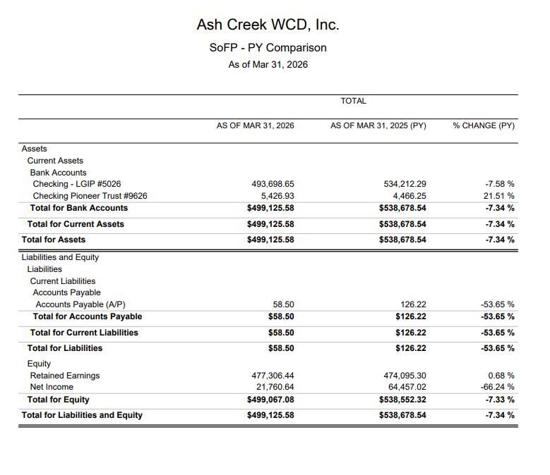

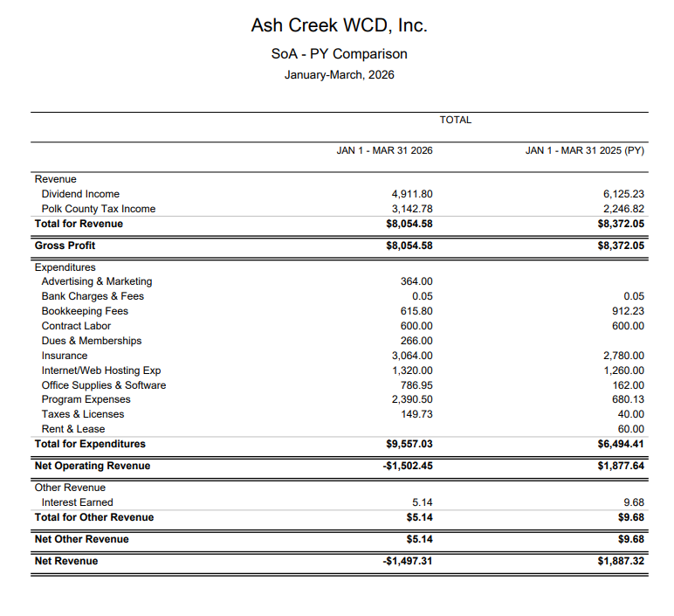

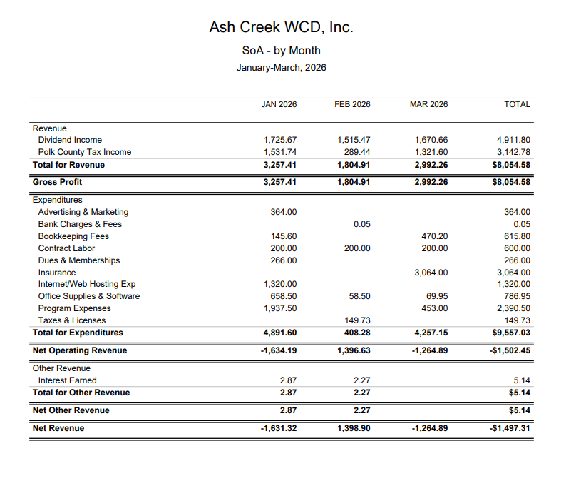
Board of Directors, Positions & Terms, updated June, 2026

Mailing Address & Phone Number for all Directors:
PO Box 81, Independence, OR 97351, 503 779-9869

Director #1
Tom Wilson, President & Treasurer
Term: 2027
Email: director1@ashcreekwcd.com

Director #2
Christina Tinsdell
Term: 2027
Email: director2@ashcreekwcd.com

Director #3
Madeline Fisher
Term expires: 2029
Email: director3@ashcreekwcd.com

Director #4
Molly Barbano
Term expires: 2028
Email: director4@ashcreekwcd.com

Director #5
Position vacant
Term expires: 2028
Email: director5@ashcreekwcd.com

Director #6
Ed Matteo, Vice President
Term expires: 2027
Email: director6@ashcreekwcd.com

Director #7
Lauren Zatkos
Term expires: 2029
Email: director7@ashcreekwcd.com

Director #8:
Position vacant
Term expires: 2027
Email:
Director8@ashcreekwcd.com

Director #9
Position vacant
Term expires: 2029
Email: director9@ashcreekwcd.com

Content/Links for electronic correspondence:
From SDAO:
https://www.magnetmail.net/actions/email_web_version.cfm?ep=aiG7TXw8p6eAbFY-OXtJeeh-YEJi5KifS4hIjg748XpNgjcj3VQ4IQW_IMzfpLYoFiejrwXYhefuRMj9SsWiTSX26EraZRRVfCPj9aI0-jRxu6MM5Pz-ChsdVR-Zcyrh
https://www.magnetmail.net/actions/email_web_version.cfm?ep=aiG7TXw8p6eAbFY-OXtJeeh-YEJi5KifS4hIjg748XrJqnVFro1dM73bjs-2o5ziJqYraXTU-p8yZ5cGKQgPLfS08P0Z0TOzTgusZFujd7EabbeYSqosZnEbTqzMhtop
https://www.magnetmail.net/actions/email_web_version.cfm?ep=aiG7TXw8p6eAbFY-OXtJeeh-YEJi5KifS4hIjg748XrmhG9P3o86hkvYTp9dHDqOjVr4QU7IKkwc5S7ldqOWvfflydR3BK_QRA_5C0OQeX5bMcJ6pF37bEfU5ieAOP__
https://www.magnetmail.net/actions/email_web_version.cfm?ep=aiG7TXw8p6eAbFY-OXtJeeh-YEJi5KifS4hIjg748Xq16SFXqLGHS515uLI6SqceqRcLRLXNrlR3nuiAWQ-I1osx4jSfH1T7yvUP_hufkG5Mu2ede9jXBsaI00VH6qGH
https://www.magnetmail.net/actions/email_web_version.cfm?ep=aiG7TXw8p6eAbFY-OXtJeeh-YEJi5KifS4hIjg748Xr60IpY_V6hUvbrQAW1SwAmuZkVJWf1q19pTb3xW65sbOzwidlm-jHnfvW60RaLItk5R9I1-wtGjFNMxQkI443B

https://www.magnetmail.net/actions/email_web_version.cfm?ep=aiG7TXw8p6eAbFY-OXtJeeh-YEJi5KifS4hIjg748Xoi_ew4zv9oPktjUSvo7WJ_slPqz-BWqmf33PsTos2VgsTL3cc4k6FdIeVDBivhPBr3zEcC0Ubj6LzRCB2cZWGZ

https://www.magnetmail.net/actions/email_web_version.cfm?ep=aiG7TXw8p6eAbFY-OXtJeeh-YEJi5KifS4hIjg748XqYBckHIltpMj4scBaFXf9VqMWT-U545oW_CjLrfZYnMl6Qad1t6e_5qyHy1dO-5Pb7VAr0VMV1aWaRE6-O6Rzp

Oath of Office

I, _______________________________, do solemnly swear, that I will support the Constitution of the United States, the Constitution of the State of Oregon, the laws thereof, and the policies of the Ash Creek Water Control District, and that I will faithfully discharge the duties of Director according to the best of my ability, so help me God.

Done, this ______ day of ________________________

__________________________________________

Attest:

________________________________________
Name

________________________________________
Title

ASH CREEK WATER CONTROL DISTRICT
Resolution #2026-01 - RESOLUTION ADOPTING THE BUDGET

BE IT RESOLVED THAT the Board of Directors of the Ash Creek Water Control District hereby adopts the budget for FY 2026-2028 in the total of $673,800 now on file with the ACWC District at distsec@ashcreekwcd.com or on our website.

RESOLUTION MAKING APPROPRIATIONS

General Fund
Personal Services $0
Materials & Services $333,040
Capital Outlay $0
Transfers $0
Contingency $75,000
Total $408,040

Project Reserve Fund
Personal Services $0
Materials & Services $0
Capital Outlay $0
Transfers $0
Contingency $0
Total $0
Debt Service Fund $0

TOTAL APPROPRIATIONS
ALL FUNDS $408,040
UNAPPROPRIATED ENDING FUND BALANCE AND RESERVES $265,760

RESOLUTION IMPOSING THE TAX
BE IT RESOLVED THAT the following ad valorem property taxes are hereby imposed for tax year 2026-27 and 2027-28 upon the assessed value of all taxable property within the district:
- At the rate of $.1069 Per $1000 of assessed value for permanent tax rate.

RESOLUTION CATEGORIZING THE TAX
BE IT RESOLVED THAT the taxes imposed for FY 2026-27 and FY 2027-28 are hereby categorized for the purposes of Article XI section 11b as:

General Government Limitations Excluded from Limitation
Tax Year 2026-27
General Fund $.0169 / $1000 $0
Debt Service Fund $0 $0
Tax Year 2027-28
General Fund $.0169 / $1000 $0
Debt Service Fund $0 $0

The above resolution statements were approved and declared adopted on the 6th day of June 2026.

Tom H. Wilson ___________________________
Chair Signatur

