Ash Creek Water Control District
Board Meeting – July 10, 2025
Board meeting begins at 6:30 PM
The meeting will be an in-person event held at Indy Commons.
Zoom will also be available: https://us06web.zoom.us/j/82158510794
AGENDA, July 10, 2025 meeting
- Call to Order
- Roll Call
Brooke Getty
Madeline Fisher
Tom Wilson
Molly Barbano
Lauren Vatkos
Ed Matteo
Todd Whitaker
Emmanuel Goicochea
Amy Albrich
Write-in: Lauren Vatkos
Write-in: Anne Scheck (declined)
Marilyn Morton absent – will meeting be recorded?
- Election of Officers
- Swearing in of newly re-elected and elected Board members
- Approval of Minutes – June 5, 2025 (minutes attached)
- Treasurer’s Report
- Audience Comments
- Director Comments
- Reports
- Finance: Monthly Report
- Phone: Monthly Report
- Nutria: Monthly Report
- Precipitation: Monthly Report
- Engineer’s Report
- Education Grants
- Policies & Procedures manual
- Unfinished Business
- Final May Election Results (detailed on several pages, attached)
- Bank account/LGIP signers/authorizations
- Formation of Regional Mid-Willamette West Waterway Partnership
- Trestle Cleanup (revisit as needed)
- New Business, Miscellaneous Business/Information Items
- Correspondence
12. Adjournment & next meeting

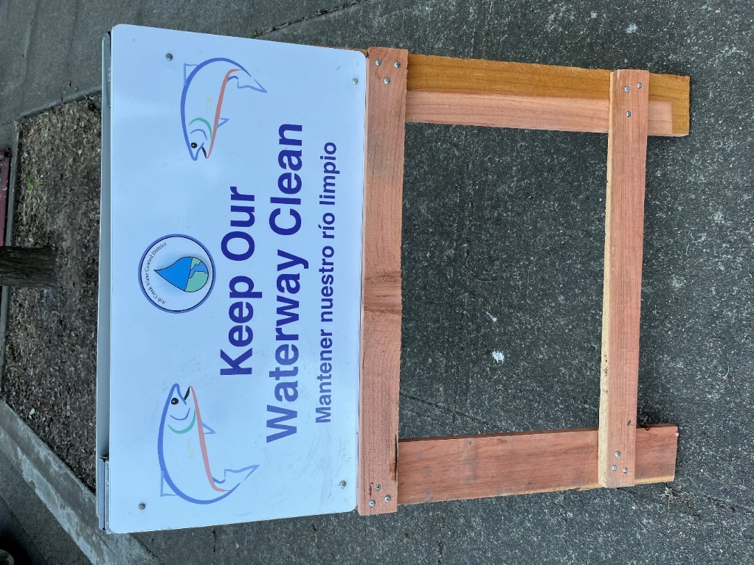
New ACWCD sidewalk sign board for use during meetings
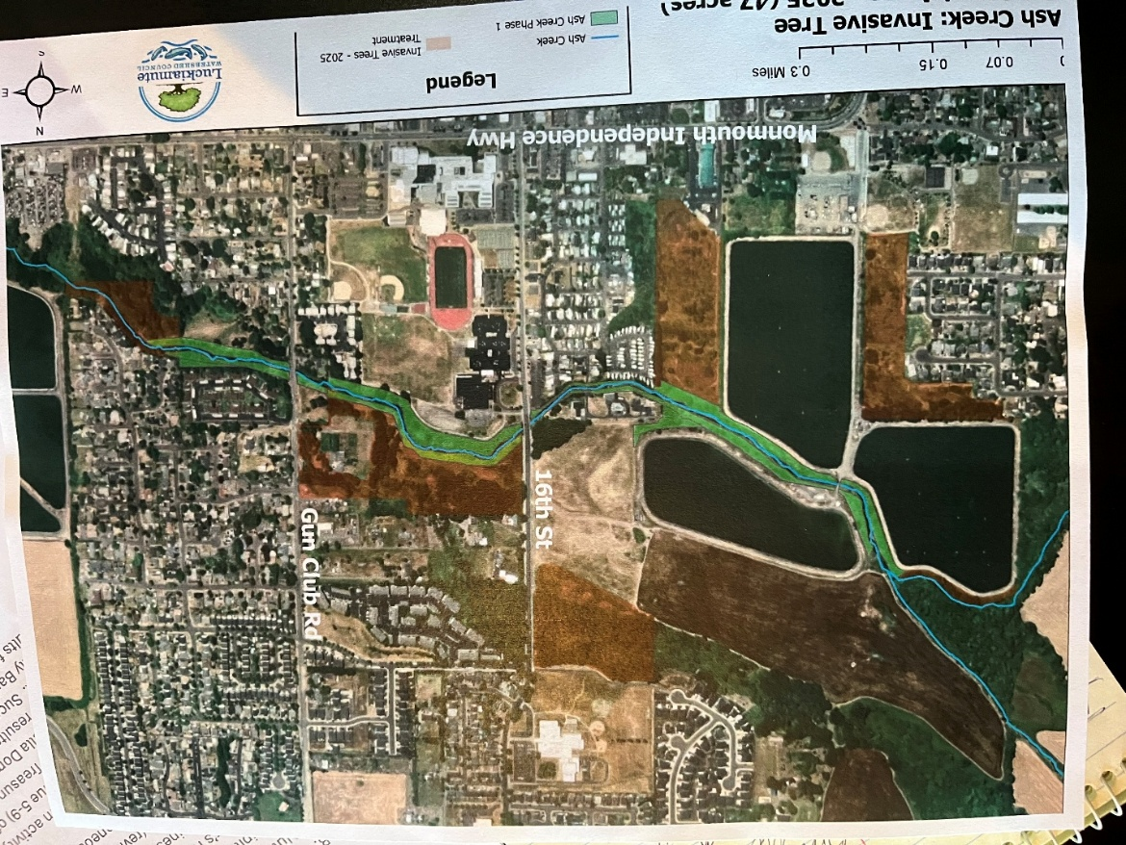
Work done by Luckiamute Watershed Council project is indicated by the brown area between 16th & Gun Club Road.

Documents following include:
Minutes from June meeting

Financial recap of latest information available from institutions.

Board of Directors, Positions & Terms

Full report on May 2025 election

Links for communications from SDAO

Content/Links for electronic correspondence received since last meeting

Draft Memorandum of Understanding for the Mid-Willamette West Waterway Partnership

Document to be copied/used for swearing in of new board members
Ash Creek Water Control District Minutes, 6-5-25,
6:30 PM, Indy Commons
- Chairman Mancil Russell called the meeting to order at 6:30 PM
- Roll Call: Present, Mancil Russell, Brooke Getty, Andrea Melendy, Madeline Fisher, Tom Wilson, Molly Barbano, Lauren Vatkos, Ed Matteo, Todd Whitaker, Jordan Perez (Guest), Marilyn Morton recording. Not present: Emmanuel Goicochea.
- Approval of Minutes for May 1, 2025. Some corrections were noted. Ed Matteo moved to approve the minutes as amended. Tom Wilson 2nd, motion passed unanimously.
- Audience Comments
Jordan Perez discussed the work done by Luckiamute Watershed Council which was and will continue to be funded by Ash Creek Water Control District (ACWCD). Jordan highlighted the large area that was worked on (see attached map), and the scope of the work done. Then he shared a video also detailing the work done. 47.25 acres were treated. The video stressed the huge ecological uplift given the area, including the massive invasive species cleanup and fire risk prevention. Thanks for ACWCD’s funding was expressed.
- Director Comments
- This is the last meeting for Andrea Melendy (20 years on the ACWCD board) and Mancil Russell (26 years of service). Thanks were given to both of them for their dedicated work. Also, Mancil has made a 2-sided sandwich board to be set up during meetings. Marilyn Morton will keep this sandwich board for set-up at future meetings. Mancil noted that new signs were needed for garbage receptacles. They should be bigger signs with a larger logo.
- Madeline Fisher is still working with Brian Dutton of WOU. So far, no evidence has shown up of any presence of the Emerald Borer.
- Reports
- Finance: Monthly Report. Tom reviewed the financial position of ACWCD. A full report was included in the agenda packet. Tom reviewed the largest transactions, which were related to work done by the Luckiamute Watershed Council. Phone: Monthly Report. None.
- Education grants: Brooke reported that there have been no applications for a grant to date. Discussion continued about best ways to reach out to teachers, and adjusting parameters, by board vote, of grant dates if needed.
- Bank Account Signers: Tom said 2 more signers are needed on the bank account to replace Mancil and Andrea who are leaving the board. All ACWCD checks require two signatures. LGIP also needs a back-up authorization person. Discussion continued.
- Phone Report: Ed said there were no significant phone calls received. Molly will take the phone for the ensuing period. There was discussion about logging calls.
- Nutria: Monthly Report (in agenda packet). Three nutrias were caught in each month (April, May). None were found in Inspiration Garden. The program is working well.
- Engineer’s Report: Todd brought contracts for spraying. Tom Wilson moved to accept the proposal stated in the contract, Ed Matteo 2nd, motion passed unanimously. The contract copies were fully executed during the meeting. Marilyn will keep one with ACWCD records and Todd will return the other to the contractor. An insurance binder from the contractor was also provided. Todd detailed the ongoing maintenance program. Discussion continued about that program. Brooke proposed focusing on the details and specifics of these projects when preparing the 10-year plan. Discussion continued about the 10-year plan, including contacting landowners, research into existing and new easements, and working with local municipalities.
- Precipitation: Monthly report, provided by Madeline:
  - May 2025, .93”
  - May 2024, 3.090”
  - May 2023, .36”
  - May 2022, 4.46”
  - May 2021, 1.07”
- Policies and Procedures subcommittee/manual was discussed. Todd has a copy of the existing manual and will get it to Tom. Marilyn offered to digitize it if necessary.
- Unfinished Business
- Trestle Cleanup (revisit as needed). Jordan discussed work Luckiamute Watershed Council has done and will do concerning the trestle. The railroad has “shelved” the idea for now. Organized volunteer work may be effective in continuing this project.
- New Business, Miscellaneous Business/Information Items
- Copies of electronic correspondence received were in the agenda packet.
- May Election. Officially elected to fill board positions on ACWCD: Madeline Fisher (position 3), Molly Barbano (position 4), Brooke Getty (position 5) and Amy Albrich (position 8). To the board’s knowledge Amy Albrich has not been involved in ACWCD, but had filed for election with the county. It is hoped that after the election is fully certified on June 10 that ACWCD will receive information about both Ms. Albrich and write-in results for positions 7 and 9.
- Adjournment: Andrea Melendy moved to adjourn, Brooke Getty 2nd, motion passed unanimously. The next meeting will be Thursday, July 10, at 6:30 PM at Indy Commons. Marilyn noted that she will not be available for that meeting. The meeting was adjourned at 7:52 PM.

Documents following include:
- Financial recap of latest information available from institutions.

Financial Reports for Ash Creek Water Control District for 2025
Pioneer Trust Bank 2025
 |  | Date |  | Credit |  | Debit |  | Running Balance
Pioneer Trust Bank 2025
 |  | Date |  | Credit |  | Debit |  | Running Balance
Beginning Balance |  | 1/1/2025 |  |  |  |  |  | $ 5,950.93
Ascension Accounting |  | 1/2/2025 |  |  |  | $ 249.67 |  | $ 5,701.26
Ascension Accounting |  | 1/3/2025 |  |  |  | $ 54.00 |  | $ 5,647.26
2339, Marilyn Morton |  | 1/8/2025 |  |  |  | $ 200.00 |  | $ 5,447.26
2338, Streaming Annual |  | 1/10/2025 |  |  |  | $ 1,260.00 |  | $ 4,187.26
2340, SDIS Annual |  | 1/10/2025 |  |  |  | $ 2,780.00 |  | $ 1,407.26
Xfer from LGIP |  | 1/14/2025 |  | $ 5,000.00 |  |  |  | $ 6,407.26
Interest |  | 1/31/2025 |  | $ 3.63 |  |  |  | $ 6,410.89
ACH, Ascension Accounting |  | 2/5/2025 |  |  |  | $ 161.33 |  | $ 6,249.56
2341, Marilyn Morton fee |  | 2/6/2025 |  |  |  | $ 200.00 |  | $ 6,049.56
2342, Indy Commons space rental |  | 2/6/2025 |  |  |  | $ 30.00 |  | $ 6,019.56
2343, Or Sec'ty State Business renew |  | 2/24/2025 |  |  |  | $ 40.00 |  | $ 5,979.56
Interest earned |  | 2/28/2025 |  | $ 3.06 |  |  |  | $ 5,982.62
ACH, Ascension Accounting 10017 |  | 3/4/2025 |  |  |  | $ 465.23 |  | $ 5,517.39
ACH, Ascension Accounting 10038 |  | 3/4/2025 |  |  |  | $ 54.00 |  | $ 5,463.39
2344, Marilyn Morton fee |  | 3/5/2025 |  |  |  | $ 200.00 |  | $ 5,263.39
2345, Indy Commons space rental |  | 3/6/2025 |  |  |  | $ 30.00 |  | $ 5,233.39
Interest earned |  | 3/31/2025 |  | $ 2.99 |  |  |  | $ 5,236.38
2346, LWC: GW Restoration |  | 3/31/2025 |  |  |  | $ 680.13 |  | $ 4,556.25
ACH Ascension Accounting 10115 |  | 3/31/2025 |  |  |  | $ 90.00 |  | $ 4,466.25
2347, Marilyn Morton fee |  | 4/3/2025 |  |  |  | $ 200.00 |  | $ 4,266.25
2348, Indy Commons (Board mtg) |  | 4/3/2025 |  |  |  | $ 40.00 |  | $ 4,226.25
ACH Ascention Accounting 10192 |  | 4/3/2025 |  |  |  | $ 54.00 |  | $ 4,172.25
2349, LWC, Ash Creek Contract |  | 4/8/2025 |  |  |  | $ 14,593.27 |  | $ (10,421.02)
LGIP ACH Redemption |  | 4/9/2025 |  | $ 15,000.00 |  |  |  | $ 4,578.98
Interest Earned |  | 4/30/2025 |  | $ 2.50 |  |  |  | $ 4,581.48
2350, Marilyn Morton fee |  | 5/1/2025 |  |  |  | $ 200.00 |  | $ 4,381.48
2351, Indy Commons space rental |  | 5/1/2025 |  |  |  | $ 20.00 |  | $ 4,361.48
2352, Affordable Storage rental |  | 5/1/2025 |  |  |  | $ 605.00 |  | $ 3,756.48
2353, Tom Wilson, email reimb. |  | 5/20/2025 |  |  |  | $ 559.90 |  | $ 3,196.58
2354, LWC AC Reneg Contract |  | 5/28/2025 |  |  |  | $ 51,174.53 |  | $ (47,977.95)
LGIP ACH Redemption |  | 5/31/2025 |  | $ 55,000.00 |  |  |  | $ 7,022.05
ACH, Ascension Accounting |  | 5/28/2025 |  |  |  | $ 102.75 |  | $ 6,919.30
LGIP - State of Oregon, for 2025
 |  | Date |  | Credit |  | Debit |  | Running Balance
Beginning Balance |  | 1/1/2025 |  |  |  |  |  | $ 530,840.29
Polk County Treasury, Tax |  | 1/8/2025 |  | $ 847.00 |  |  |  | $ 531,687.29
Debits, Transfer to checking |  | 1/14/2025 |  |  |  | $ 5,000.00 |  | $ 526,687.29
Polk County Treasury, Tax |  | 2/3/2025 |  | $ 2,125.00 |  |  |  | $ 528,812.29
Polk County Treasury, Tax |  | 3/1/2025 |  | $ 2,120.00 |  |  |  | $ 530,932.29
Polk County Treasury, Tax |  | 4/1/2025 |  | $ 3,280.00 |  |  |  | $ 534,212.29
Polk County Treasury, Tax |  | 4/7/2025 |  | $ 286.05 |  |  |  | $ 534,498.34
ACH Redemption |  | 4/9/2025 |  |  |  | $ 15,000.00 |  | $ 519,498.34
Accrual Income Div Reinvestment |  | 5/1/2025 |  | $ 1,979.04 |  |  |  | $ 521,477.38
Debits, Transfer to checking |  | 5/31/2025 |  |  |  | $ 55,000.00 |  | $ 466,477.38
LGIP Prepaid Visa Card,205
 |  | Date |  | Credit |  | Debit |  | Running Balance
Beginning Balance |  | 1/1/2025 |  |  |  |  |  | $ 247.26
Debits, none to date |  |  |  |  |  |  |  | $ 247.26
Credits, none to date |  |  |  |  |  |  |  | $ 247.26

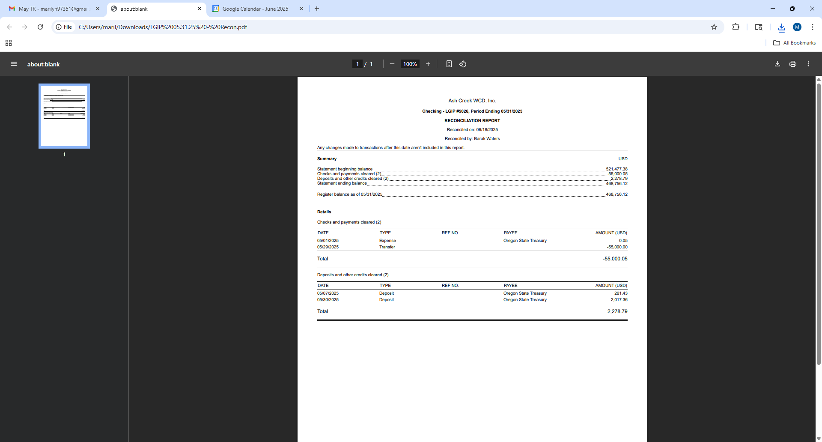
WITH ELECTION RESULTS:
Board of Directors, Positions & Terms after May 20 election

Mailing Address & Phone Number for all Directors:
PO Box 81, Independence, OR 97351
503 779-9869

Director #1
Tom Wilson
Term: 2027
Email: director1@ashcreekwcd.com

Director #2
Emmanuel Goicochea
Term expires: 2027
Email: director2@ashcreekwcd.com

Director #3
Madeline Fisher
Term expires: 2029
Email: director3@ashcreekwcd.com

Director #4
Molly Barbano
Term expires: 2028
Email: director4@ashcreekwcd.com

Director #5
Brooke Getty
Term expires: 2028
Email: director5@ashcreekwcd.com

Director #6
Ed Matteo
Term expires: 2027
Email: director6@ashcreekwcd.com

Director #7
Lauren Vatkos
Term expires: 2029
Email: director7@ashcreekwcd.com

Director #8:
Amy Albrich
Term expires: 2027
Email:
Director8@ashcreekwcd.com

Director #9
Position remains vacant
Term expires: 2029
Email: director9@ashcreekwcd.com

ELECTION RESULTS from Polk County:
The first page, below, is an official acceptance of the election, which the secretary signed and returned on 7-2-25. The next page contains the certified votes for board positions, leaving position #9 unfilled at this time. The next two pages show whose names were written in on the ballots.

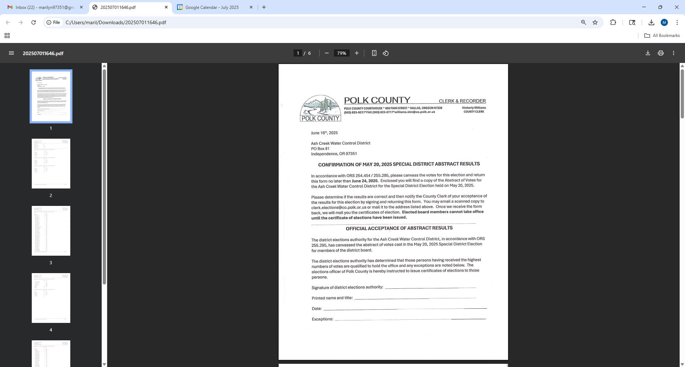

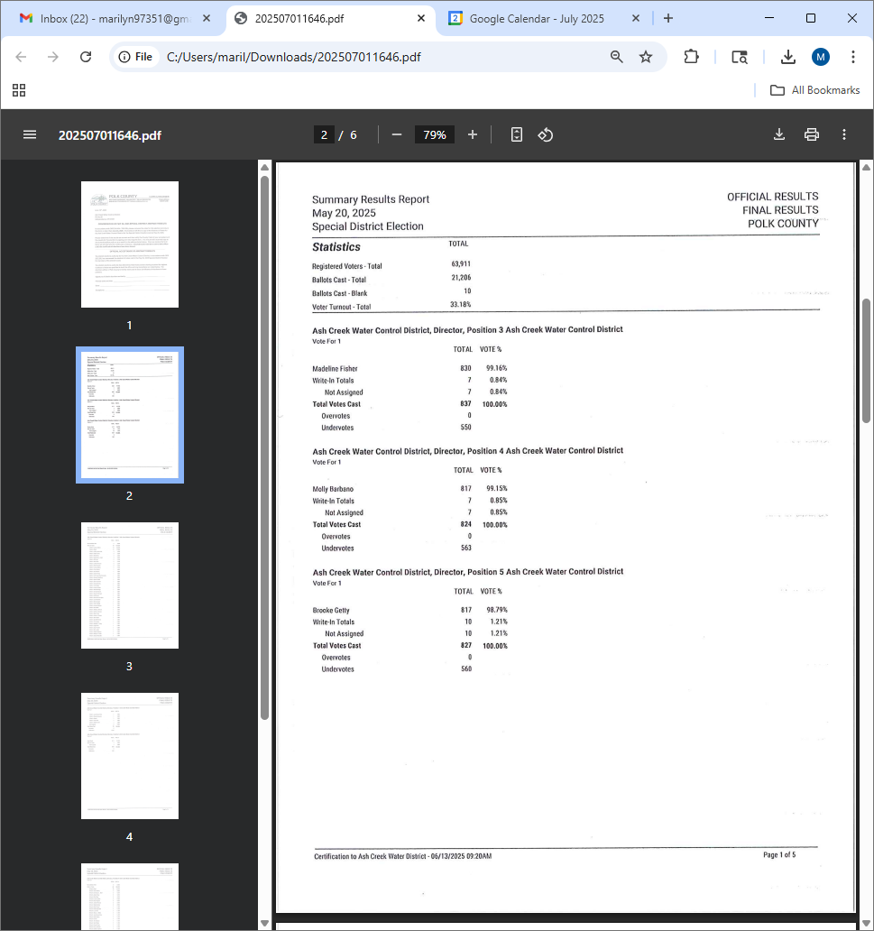
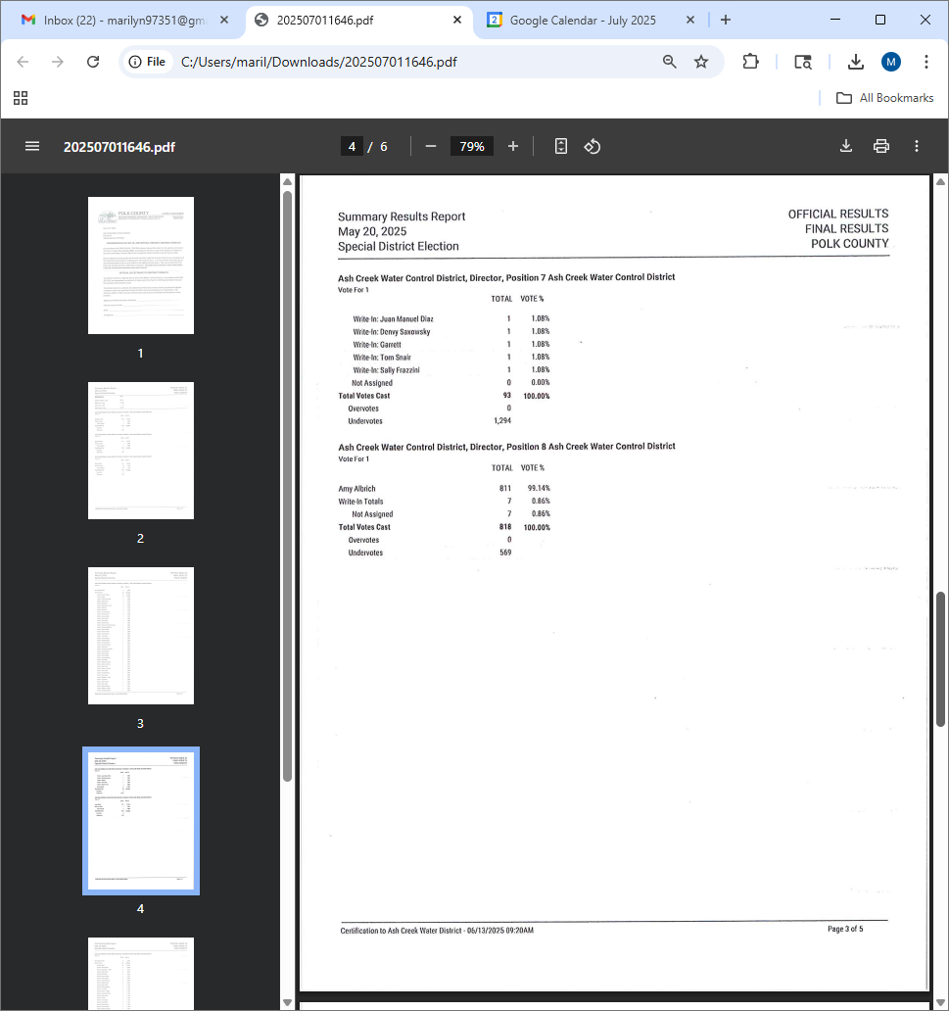
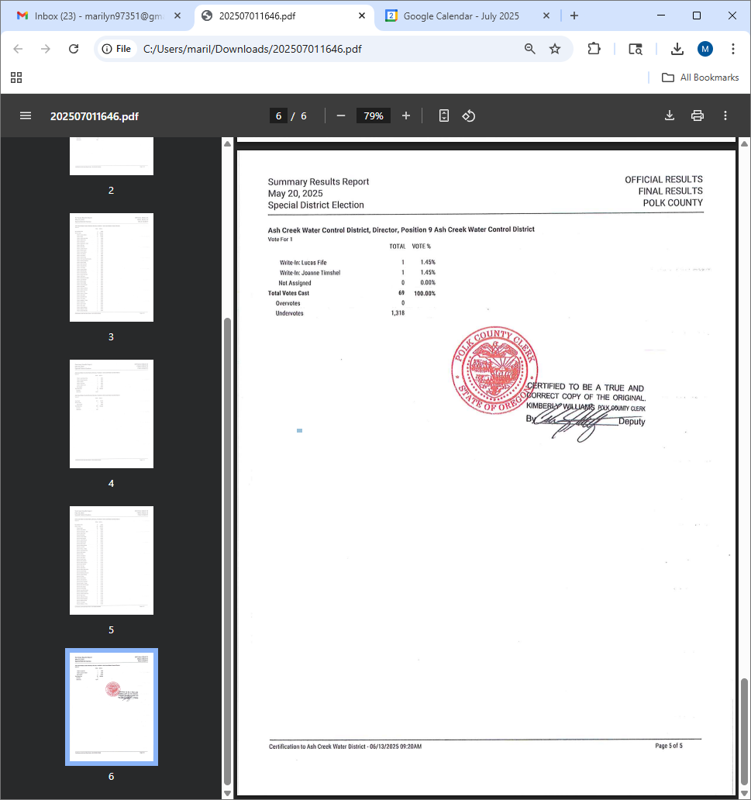
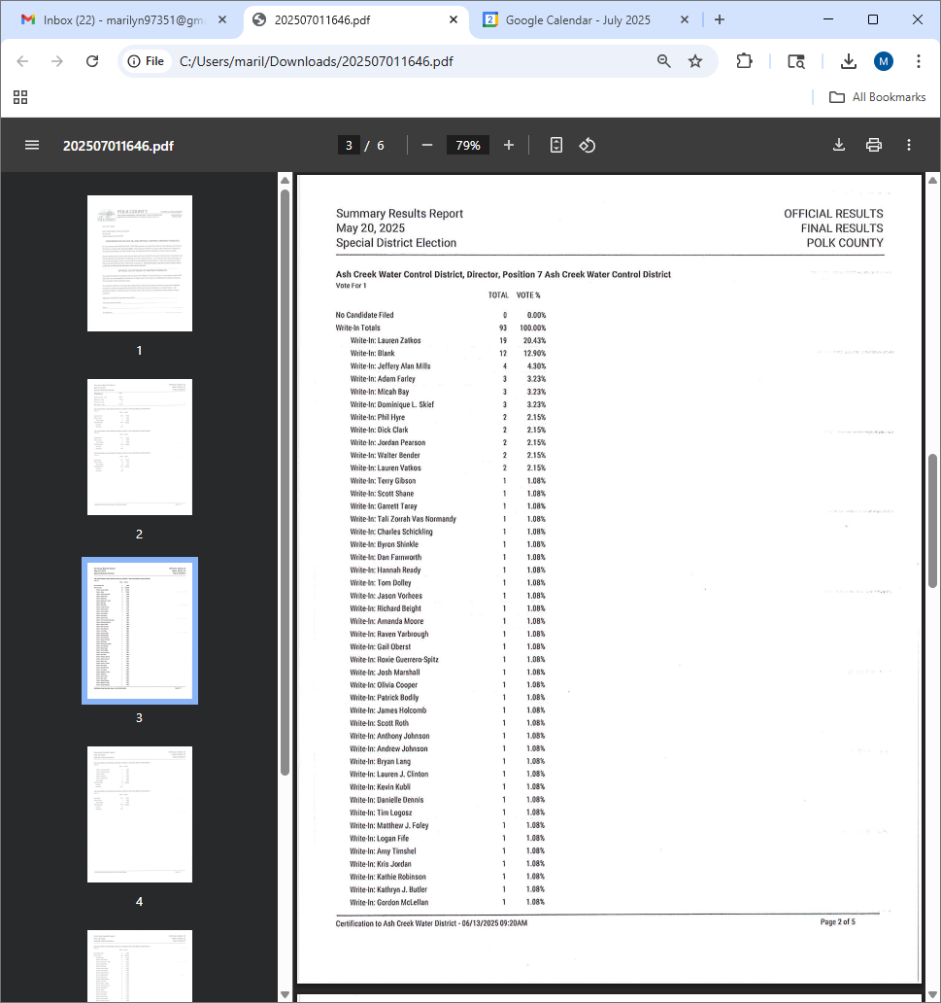
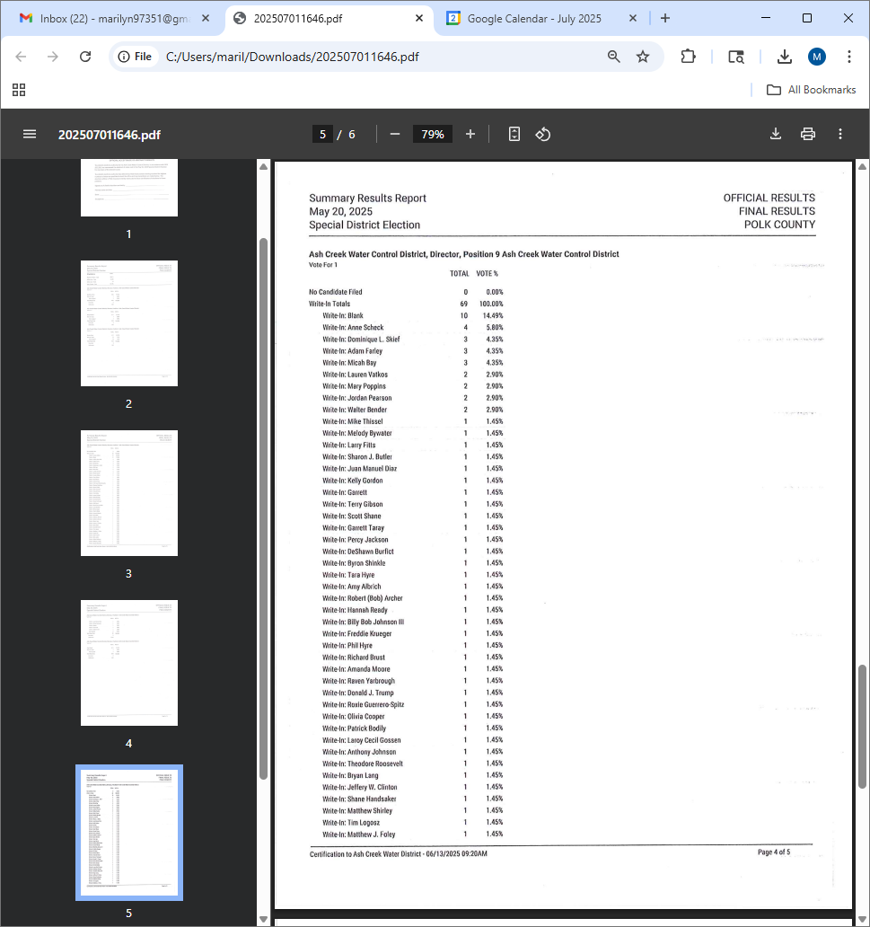

Information received from Kim Williams at the Polk County Elections office:
- From Kim Williams: You had 2 positions in which nobody filed. I have sent a congratulatory letter and write-in acceptance to one of the individuals who won by write-in, but the other write-in winner I can't find in Polk County. The only Anne Scheck I can find lives in Salem, on the Marion County side. I am reaching out to see if you know who this person is and if they perhaps go by a different name? If not, I will send a letter out declaring the position vacant.
- To Kim Williams: Anne Scheck resides in Salem, though may still own property at the Independence Air Park. Ms. Scheck may not be qualified, as I understand it, to fill a position on the ACWCD board. MM

From Anne Scheck, 6-25-25, 4:17 PM

Dear Ash Creek Water Control Board Members,
Thank you so much. I've been notified by the Polk County Clerk, Kim Williams, that I was elected to your board by write-in votes at the May election.
So very flattering, confidence-building and mightily appreciated.
But, as a journalist, board service is prohibited as a potential conflict of interest.
I'd dropped off -- and out of coverage -- of your board after certain Independence-city-affiliated individual(s) spurned press inquiries over the past 18 months from Trammart News when, at times, I felt such a dire need for answers. Why was I concerned this could that have impacted your hard-working group?
I was apprehensive that it would -- you have members that serve in both ACWCD and in city capacities, and I didn't want to be a complicating factor.
But, as I advised Ms. Williams, it's time to re-think that ... so many ACWCD accomplishments are escaping the spotlight they deserve.
I will be attending some of your group meetings now, from time to time; I will try to be better at keeping up with the district. I am sorry I missed so many...
Thank you. Anne Scheck @ Trammart News & Publishing

Content/Links for electronic correspondence:
From SDAO:
https://www.magnetmail.net/actions/email_web_version.cfm?ep=WR3zYkspt41BnMmEPt_H_dAwjixEfcDBGW2qLaDnmOiA8AN-LO_NyQkVHMJRruggslDMQiREVhDQe5CePczo1BSz1xHaXUtM7vvuPBajqQbmtkfLNHZEO4INhbcmOTHX
https://www.magnetmail.net/actions/email_web_version.cfm?ep=WR3zYkspt41BnMmEPt_H_dAwjixEfcDBGW2qLaDnmOjB1pBJbS83Qq1U3a4lm5uT2i06Q0hH1R5GSodl_eJmefZWznLIQCf4GQDMdk9Hr52Ia20XKBEcJ4fWEuj84RFF
https://www.magnetmail.net/actions/email_web_version.cfm?ep=WR3zYkspt41BnMmEPt_H_dAwjixEfcDBGW2qLaDnmOiIfHZrEmhkene6wcgCfr3BUS3-szDtzcTOaguKnOlNPqOFjIAlxoW_xtbCGScd92U_HFC5PeN7mbMDOxlCqwm2
https://www.magnetmail.net/actions/email_web_version.cfm?ep=WR3zYkspt41BnMmEPt_H_dAwjixEfcDBGW2qLaDnmOhJDb9XO16CaobutTvwPBI9x0YGbJ0Ob89efRWTLoyV0HB-ahqBcGHGjHLpxLJii_ai2la0OCEqBrXOrRuocw31
https://www.magnetmail.net/actions/email_web_version.cfm?ep=WR3zYkspt41BnMmEPt_H_dAwjixEfcDBGW2qLaDnmOha2Tbdx1sEwq16HqIZcdaMogzILgRMcmB4S21tf0Lbp-G22Fj3L0hD4uuHCbaXzVMU5vT_OWi2ZIelsJdJI1l4
https://www.magnetmail.net/actions/email_web_version.cfm?ep=WR3zYkspt41BnMmEPt_H_dAwjixEfcDBGW2qLaDnmOiwGhTeplLhmtHH2tgiOY9KSKiJgpQcfE5dj47v_8tJ_L99N5GKjLGtJ1jCKC8DkVKGw17SclhnJ54ZcSWQ03K7
https://www.magnetmail.net/actions/email_web_version.cfm?ep=WR3zYkspt41BnMmEPt_H_dAwjixEfcDBGW2qLaDnmOgyoeBPSeZ4fgZSqf5-vjIf374_r6oXPI47y-_T1_Yjk753Pu0M_LR0TyqTHhTszDCuvqu7aHoYGAB7twOk_IAy
https://www.magnetmail.net/actions/email_web_version.cfm?ep=WR3zYkspt41BnMmEPt_H_dAwjixEfcDBGW2qLaDnmOhyeym8Qv2p648ZpNQOYc_r_jZB0JLDyZ4x9aRhHlhgoBDkhjkP2XXONRLWrk81BdwiF_kZqqBlEBhBYfXThblT

Regional Group - Compilation of Comments, 6-11-25, 9:24 AM  From: Elizabeth Sagmiller, to Mark Landau, Mike Quisenberry, AJ Foscoli, Jennifer Ward,  Jordan Perez, Suzanne Teller, Aubrey Cloud, Gerald Fisher, J Creekmore, Distsec ACWCD,  Kayla Silverman, Tom Wilson, Marc Bell, Morgan Neil, Mancil Russell  I'm going to make an attempt to sort out the comments floating around out there. Thank you to everyone that's taken a moment to check in.  Many of you have asked what the purpose of the group is. Mark Landau sent out a thumbnail sketch of the purpose of the group that was spot on. It would be useful for you to look back at that message. I have also attached the draft Memorandum of Understanding which covers purpose and goal for the group.  In an effort to sum it up in a short and sweet list:  1. We're a regional group of agencies that have an interest in promoting water quality in our area.  2. In order to make the best use of staff time and agency dollars, we will seek to share messaging, events of interest, innovative ideas, etc. These actions broaden the reach of what we can do alone.  3. Collectively the group will hold at least one public event per year that reaches a broad audience with water quality information.  It seems as though we have a couple of people suggesting that we use google docs for recordkeeping - thank you Suzanne, Morgan, and Kayla.  And thanks Kayla for the contact list!  I think that Suzanne's idea of creating a google folder to share event information, training material, etc. Is a great idea. What do you think?  Can someone create that folder and then share it with everyone?  Mark or I will send out a Doodle Poll or gotomeet in late July to get a meeting set for July.  Best!  Elizabeth  6-11-25, 9:26 AM, from Suzanne Teller to group:  Thank you, Elizabeth!  I'd be happy to create the Shared Google Drive for us. I don't think I've seen all the responses from everyone, so can you send the contact list that Kayla provided?  6-11-25, 2:19 PM, from Suzanne Teller to group:  I've created the Shared Google Drive and shared it with most of you, however there is one person who I can't share it with since Google needs everyone to have a Google account in order to add them (even though it is fine to access the folder using your non-Google email account). This is one annoying feature I forgot! Jon Creekmore, do you have a Google email that you can share with me? Once I have that, it will allow me to add your work email. If you don't, we may have to find an alternate solution...  6-11-25, from Suzanne Teller to group:  Also, it is not allowing me to add Gerald Fisher - Gerald, please send me your google email (if you have one) as well!  6-11-25, from Gerald Fisher to group:  I don’t have a google email. Just the city one.  6-11-25, from Susanne Teller to ACWCD:  6-11-25, from Elizabeth Sagmiller to group:  In the event you missed the note from Kayla with the contact list, here it is again. Thanks Kayla!  https://docs.google.com/spreadsheets/d/1dShso1UFDhAHro4Jhk0x_qIf2NDyDHiQ5-qspLA6r_4/edit?usp=sharing  6-11-25, from Mark Landau to group:  I will be sending out Emails periodically, until our next in person meeting (August). I plan to do a Doodle poll for availability. We will have it in Monmouth and there will be an option for virtual.  The vision of this group's creation is:  1. Deliver the same Stormwater message collectively county wide.  2. Share info from each agency and see if there is overlap, or options to partner.  3. Sharing resources and equipment.  4. Posting of events on other agencies web pages.  5. Collectively applying for grants.  6. Sharing educational information.  This is just a tid bit to help get us started and we can add to the list as we move forward.  Just from our last meeting we have already seen some good come from it and we will share at the in person meeting.  Food for thought - As a joint educational effort focused at our TMDL's, next year 2026, we have a joint booth at the Polk County Fair.  Thank you for taking the time to read this email and I look forward to what this group can and will create.  Have a great rest of your week! | )
Screen shot of Regional Collaboration Group in Google Docs:
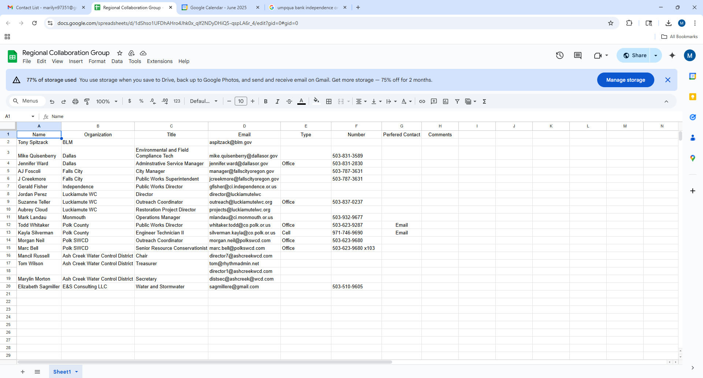

New Google Drive for regional waterway partnership
Inbox
Suzanne Teller, 6-13-25

Educational materials/brochures
Memorandum of Understanding vs1.pdf
Contact list for Regional Collaboration Group.xlsx
1. What is the Regional Waterway Partnership?

Good morning, everyone!
You should be seeing a new invitation to a Google Drive in your inbox this morning. Please use this folder for the Partnership from now on.
A couple of days ago I had invited you all to a Shared Google Drive folder, but then found out that a couple of our group do not have gmail accounts and Google doesn't allow access to Shared Drives for non-account holders. However, the regular Google folders do allow non-members to use and access files, so I switched everything over.
If you do not see the invitation in your inbox, you can join by clicking this link.
Thank you!
-Suzanne

Gerald Fisher | 9:06 AM (3 minutes ago)
Received and logging in. Thanks.
Regards,
Gerald Fisher, PE

----- D R A F T -----
MEMORANDUM OF UNDERSTANDING
Mid-Willamette West Waterway Partnership (GROUP NAME???)
(Regional Collaboration for Preservation and Protection of Watershed Health)
Mission: To provide useful information to residents of the region’s community members that demonstrates the importance of protecting local waterways for the beneficial uses of all residents. The partners of the [Name of the group] believe that clean, healthy streams help support thriving, healthy communities. Watershed health is achieved by the actions and behaviors of an engaged population. We will work together to create a positive, impactful experience that will drive environmentally sound practices within our communities.
Goal: The goal of this collaborative effort is to demonstrate that a unified regional voice can effectively share environmental messaging, reaching a broader audience than individual efforts alone. The [Name of the group] will focus on sharing resources to develop and promote public events that educate community members about local water resources and how to protect them. Resources may include such as: staff time, tools, equipment, technical expertise, participation, funding, or other support.
Partners: Local governments, watershed councils, and special districts are encouraged to join this collaborative effort to help build strong, lasting relationships. Together, we share a commitment to improving watershed health and protecting the regional environment. This project aims to Increase public awareness and community involvement in local waterway stewardship efforts.
Participation Expectations: Partners are invited to contribute resources, offer feedback, and support project initiatives as appropriate. The group will collaborate to establish a mutually agreeable schedule and determine how each partner can best contribute to the overall success of the projects.
Core Event: The [Name of the group] will organize and host at least 1 public core event annually that will serve as a focal point for the group’s efforts. The intent of the event will be to promote an aspect of watershed health that is of benefit to the audience. The objective is to establish a recognizable event that will draw new and established participation from year to year. The group may also develop other related events or provide support for existing established events that support regional watershed health education.
Logos and Permissions: An electronic version of each organization’s logo should be included in any shared project materials, and on any approved promotional material for individual websites. Shared logos help to promote the collective efforts and activities of all participating groups.
Duration: Ongoing until amended by the group.
Signatures:

OATH OF OFFICE

I, ______________________________, do solemnly swear, that I will support the Constitution of the United States, the Constitution of the State of Oregon, the laws thereof, and the policies of the Ash Creek Water Control District, and that I will faithfully discharge the duties of Director according to the best of my ability, so help me God.

Done, this ______ day of ___________, 2025

__________________________________________
(Signature)
Attest:

________________________________________
Name

________________________________________
Title

