Ash Creek Water Control District, AGENDA
Board Meeting – April 2, 2026
Board meeting begins at 6:30 PM
This is an in-person meeting at Indy Commons. To join by Zoom, please use this link:
https://us06web.zoom.us/j/82158510794?pwd=zBEajDFo31FeaehdbuRWLOkQoafd5S.1
- Call to Order
- Roll Call

Brooke Getty
Madeline Fisher
Tom Wilson
Molly Barbano
Lauren Zatkos
Ed Matteo
Todd Whitaker
Amy Albrich
Guests?
(Marilyn Morton, recording)

- Minutes of February meeting (attached)
- Milliman, Inc., will now provide actuarial valuation services for compliant SDIS members
- Certificate of insurance for Storage Unit (storage unit is not mentioned in policy from WHA)
- Audience Comments
- Director Comments
- Reports
- Finance: Monthly Report
- Phone: Monthly Report
- Nutria: Monthly Report
- Precipitation: Monthly Report
- Engineer’s Report
- Education Grants
- Unfinished Business
Continue Biennium Budget Work
Did anyone attend Storm Water Master Plan Open House in Independence?
- New Business
Anyone in addition to Molly planning to attend Luckiamute Watershed Council Spring Social, April 11?
Consideration of new board member(s)?
- Adjournment & next meeting
Documents following include:
Minutes from March meeting

Budget Calendar for 2026-2028 biennium

Financial recap of latest information available from institutions.

Board of Directors, Positions & Terms

Links for communications from SDAO

An interesting article from 1983

Oath of office, if needed

Ash Creek Water Control District, Minutes, 3-5-26, 6:30 PM, on Zoom

https://us06web.zoom.us/j/82158510794?pwd=zBEajDFo31FeaehdbuRWLOkQoafd5S.1
- Call to Order
- Roll Call. Present: Madeline Fisher, Amy Albrich, Ed Matteo, Tom Wilson, Molly Barbano, Jordan Perez, Brooke Getty, Lauren Zatkos, Marilyn Morton. Not present: Todd Whitaker, board member applicant Ms. Tisdell. No guests.
- Minutes of February meeting. Amy moved to approve the minutes, Ed 2nd, motion passed unanimously
- Audience Comments. Tom invited Jordan to be present while planning is being done. Jordan commented on work funded by ACWCD, cultural clearances. Scope of work, including surveys and archaeological report discussed. Work expected to be done shortly. They also created Ash Creek Restoration signage prepared, funded by ACWCD. Updates on several ongoing projects were discussed and information will be emailed to ACWCD.
- Director Comments. Madeline – LWC put in temperature monitor on a spike into Ash Creek on her property. Ultimate recipient of information undetermined at this time. Molly – Friends of Gentle Woods having planting on Sunday 3-8-26. This will be fill-in planting and replacement of minimal losses; plants will be of decent size. Discussion continued.
- Reports

- Finance: Monthly Report. Tom gave the financial report through January 2026.
- Phone: Lauren reported no calls.
- Nutria: Ed submitted a report. Five caught this month.
- Precipitation: Monthly Report
February 2026, 5.07”
February 2025, 5.64”
February 2024, 4.63”
February 2023, 2.91”
February 2022, 2.19”
February 2021, 5.28”

- Engineer’s Report. None at this meeting.
- Education Grants. School system did (finally) cash the check; no further report.
- Unfinished Business
- Continuing work session for 10-year strategic plan.
Tom guided the discussion of content in the 10-year plan, with specific attention to Chapter 5. He will incorporate suggestions/changes made by board members, and bring a draft to the next meeting.
Specific points of discussion:
Tom noted that the current “Appendix D” in the ACWCD 10 year plans appears to be appropriate to retain.
Todd Whitaker takes the lead in updating the 10-year plan into a final form.
Jordan Perez discussed his organization’s plans for the future and how they will be interactive with ACWCD ‘s 10 year plan and funding plans. LWC is expanding their species focus beyond only salmon. Proposals will be coming.
“Maintain resources for property owners” section from Chapter 5 was discussed, which should include educational resources as well as financial ones.
At present there is an accurate map of the district boundaries. Needs to be stored in an Art GIS account, either via purchasing it through ACWCD, or hosting on a personal account available through a board member. LWC has an account, and could maintain appropriate documents. Proper storage discussed. Include this discussion in the budget meeting.
Are any of the goals and/or methodologies outdated and do they need to be updated? Suggestions and ideas were discussed.
Is Section D still relevant, re. raising elevation of Gun Club/Godsey Road? – No, eliminate.
Discussion about how SWCD or LWC could integrate goals and activities. Past collaborations noted.
Policy Work – may need input/suggestions from Todd.
Cooperation with planning officials and regulatory agencies – still pertinent.
Issues on Flood Plain Mapping, working/interacting with other agencies still valid.
- Email subscription upgraded to allow for extended use. Expense will be reflected on future financial report.
- New Business
- Budget: Work with budget calendar. Updated as shown below.
- Ed moved to appoint Marilyn Morton as budget officer, Amy 2nd, motion passed unanimously.
- At April meeting determine the budget calendar. At April board meeting the budget will be discussed. Tom asking Mancil & Andrea (and spouses) to be on budget committee. Should be as many members of the public as there are board members.
- Reminder: Independence Storm Water Master Plan Open House March 12, 6-8 PM, Independence City Hall
- Adjournment at 7:50 PM.
- Next meeting will be April 2, 2026, 6:30 PM, at Indy Commons.

ASH CREEK WATER CONTROL DISTRICT

BUDGET CALENDAR
FY 2026-28

1. Budget Officer Appointed March 5, 2026

2. Proposed Budget Prepared March/April, 2026

3. Budget Officer Publishes Notice (2x) Apr 8 & 22, 2026
'Notice of Budget Committee Meeting'

4. Budget Committee Meets, 6:30 p.m. Between April 24-30, 2026
-Confirm meeting place (Indy
Commons?)
-Additional meetings as needed

5. Budget Committee Approves Budget No later than mid-May 2026
(it can be done at the first meeting, above) (Although, it can be approved later if needed, deadline 6-30-26 at midnight.)

6. Notice Published May 29, 2026
'Budget Summary and Notice of (due to IO noon, 5/24)
Budget Hearing'

7. *Budget Hearing Held June 5, 2026 (regular mtg date)
Budget Adopted, Appropriations Made, (Budget must be adopted NLT
Taxes Imposed & Categorized 6/30)

8. Taxes Certified to County Assessor No later than July 15, 2026

9. Copy of Budget to County Clerk No later than Sept. 30, 2026

APPROVED BUDGT from 2024-2026 Biennium, for reference
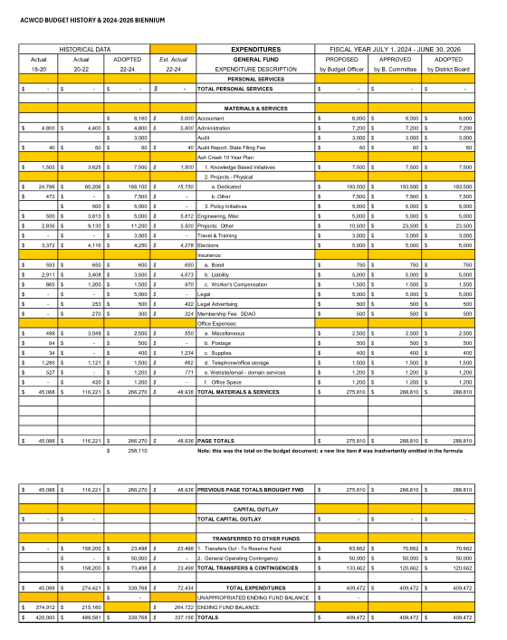
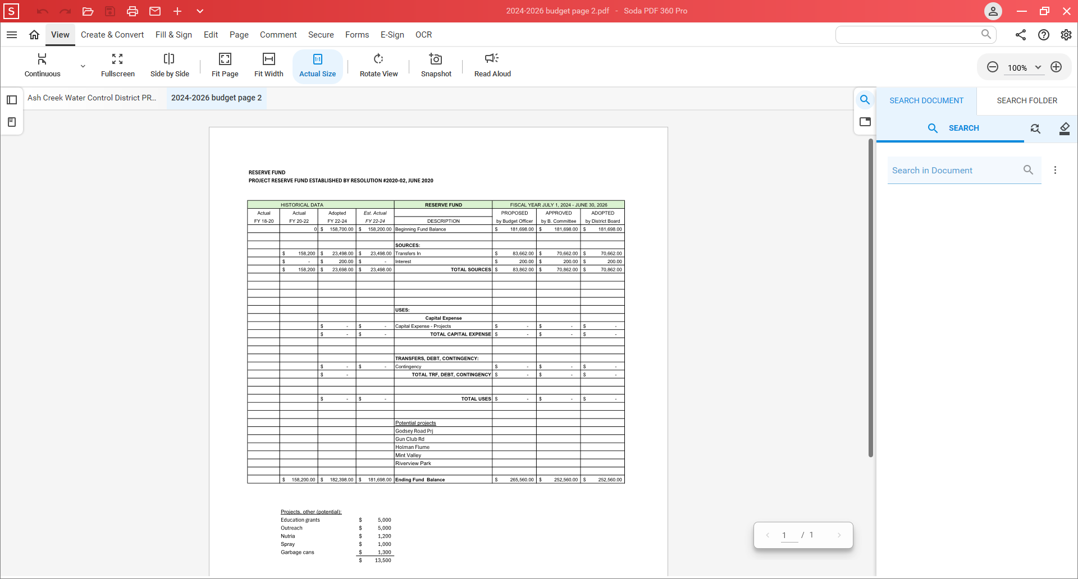
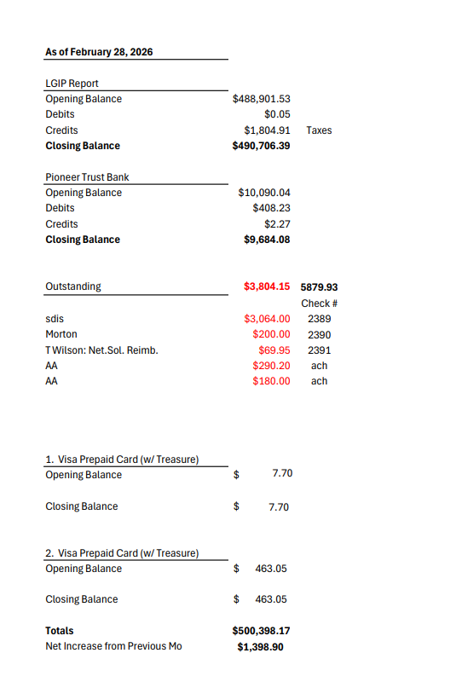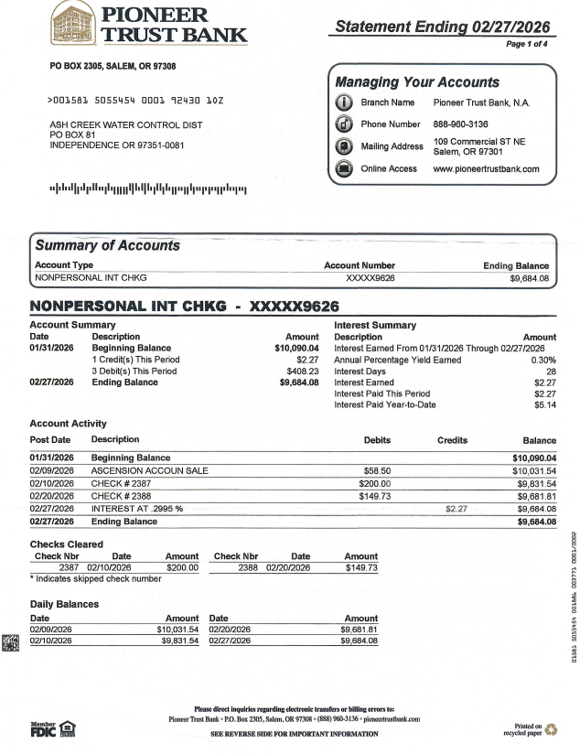

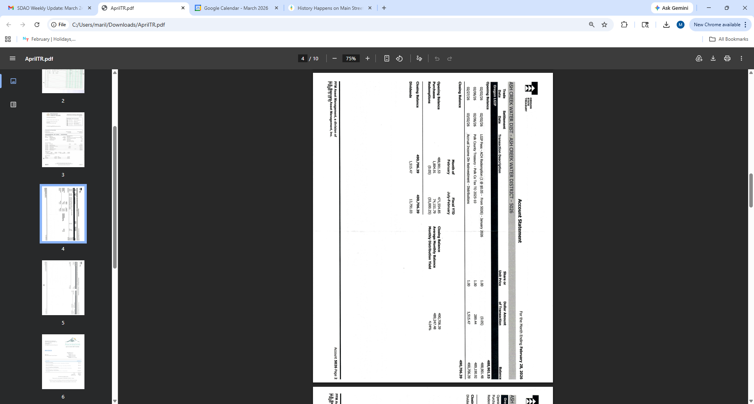
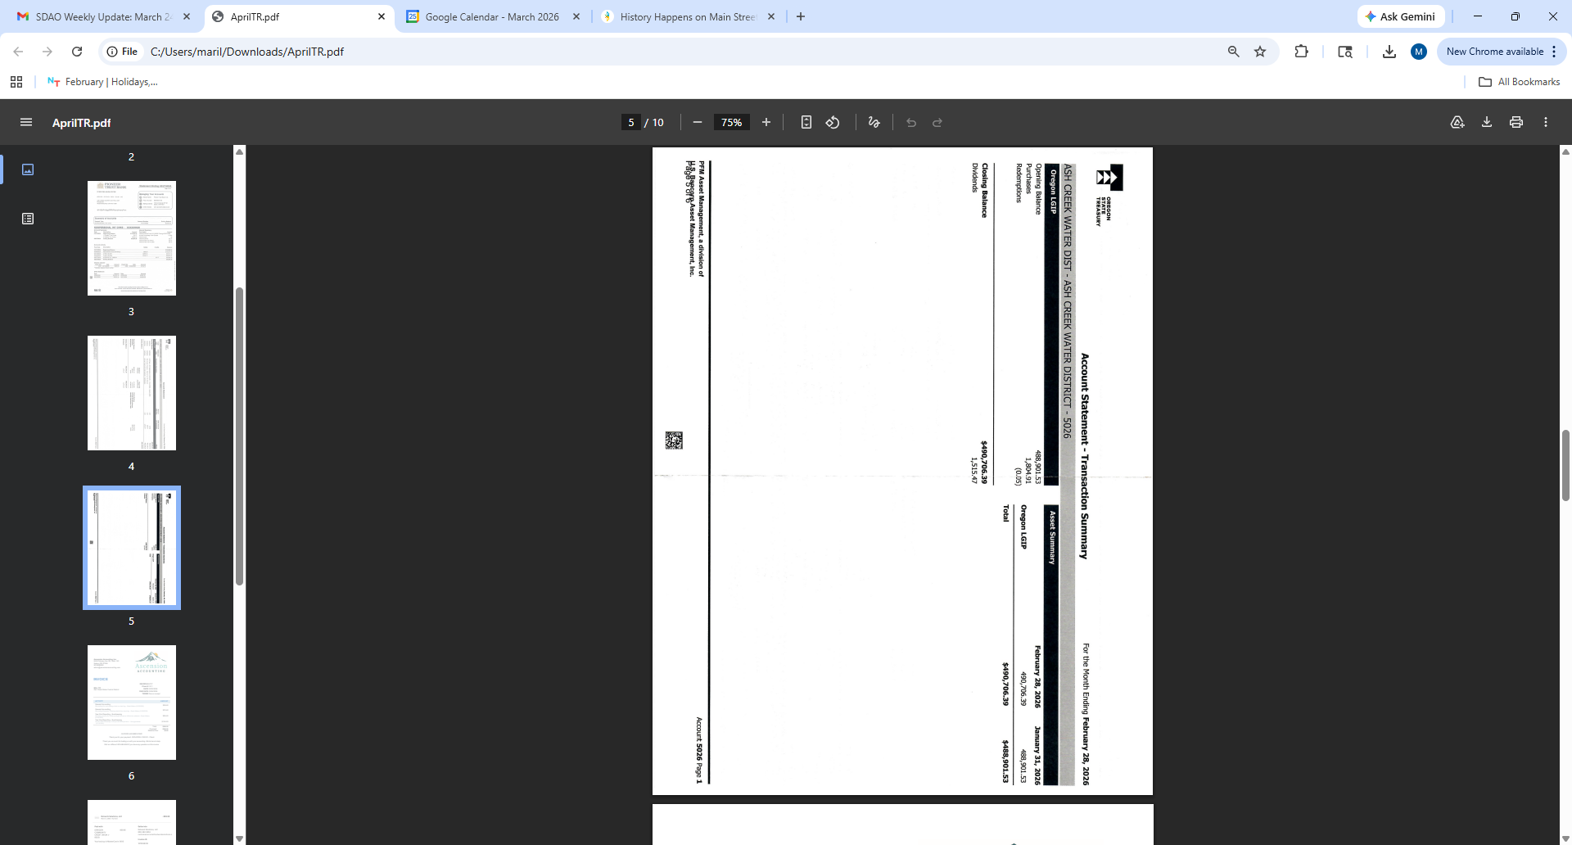
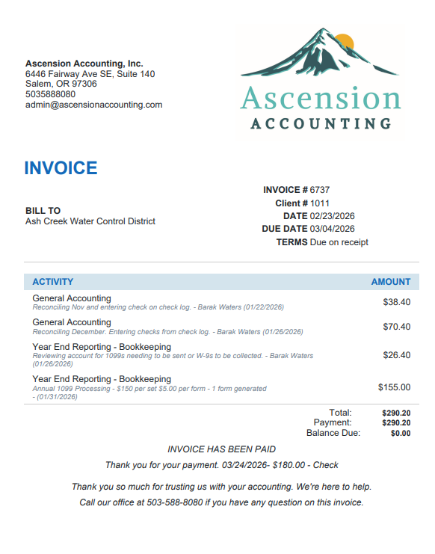

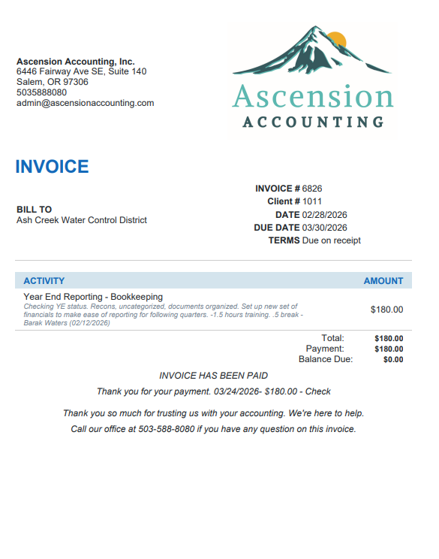

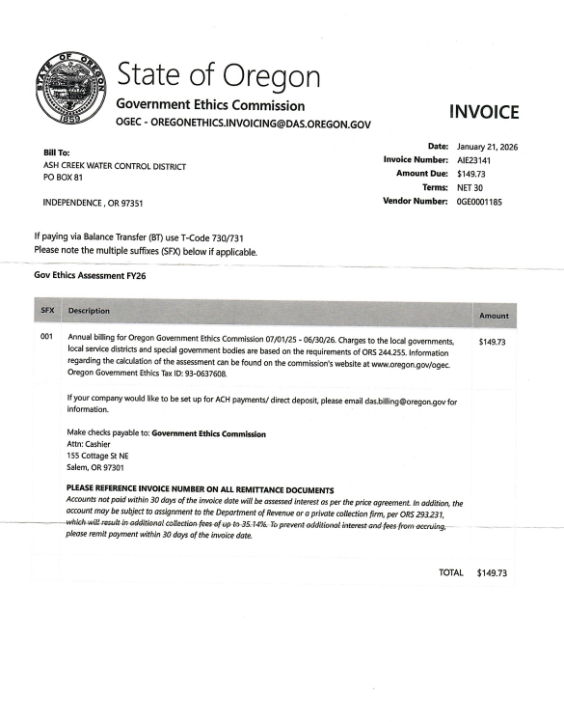

Board of Directors, Positions & Terms after May 20 election

Mailing Address & Phone Number for all Directors:
PO Box 81, Independence, OR 97351, 503 779-9869

Director #1
Tom Wilson, President & Treasurer
Term: 2027
Email: director1@ashcreekwcd.com

Director #2
Tisdell ? (or pos. 9?)
Next election: 2027
Email: director2@ashcreekwcd.com

Director #3
Madeline Fisher
Term expires: 2029
Email: director3@ashcreekwcd.com

Director #4
Molly Barbano
Term expires: 2028
Email: director4@ashcreekwcd.com

Director #5
Brooke Getty
Term expires: 2028
Email: director5@ashcreekwcd.com

Director #6
Ed Matteo, Vice President
Term expires: 2027
Email: director6@ashcreekwcd.com

Director #7
Lauren Zatkos
Term expires: 2029
Email: director7@ashcreekwcd.com

Director #8:
Amy Albrich
Term expires: 2027
Email:
Director8@ashcreekwcd.com

Director #9
Position remains vacant
Term expires: 2029
Email: director9@ashcreekwcd.com

Content/Links for electronic correspondence:
From SDAO:
https://www.magnetmail.net/actions/email_web_version.cfm?ep=aiG7TXw8p6eAbFY-OXtJeeh-YEJi5KifS4hIjg748Xoa8k6TNoiPOnvDV9X2r7INGZHJjVs8aeW22cjNahdq7n_0_V24fEyWvzxtunSY4EczrytFDuPodj9AxZ_hH8v8
https://www.magnetmail.net/actions/email_web_version.cfm?ep=aiG7TXw8p6eAbFY-OXtJeeh-YEJi5KifS4hIjg748XpahaZw9B4GeClt9DJS4I56cm0dLqBScgcemQjuaZvdJKCvZsH_BPmJRFWs_70xloXcygMkFf2G60ebZemqjhLs
https://www.magnetmail.net/actions/email_web_version.cfm?ep=aiG7TXw8p6eAbFY-OXtJeeh-YEJi5KifS4hIjg748XrzYt2lxnB2dLppRFixZb-Sd_UsLX0eolkgwiFzr5tbm4M0zgofOLz-xvh3E8C_LGHz6JCzeKiwZ75-9jyzPqOY
https://www.magnetmail.net/actions/email_web_version.cfm?ep=aiG7TXw8p6eAbFY-OXtJeeh-YEJi5KifS4hIjg748XpwC_imiqd9O2pxXXtzOlPWPG7QhhdjIQh1rc80jO7u8ajumfVMjUmJu7KSKa_wdqeP8BTW67gmWlDPPpBNkMwU

Interesting article!
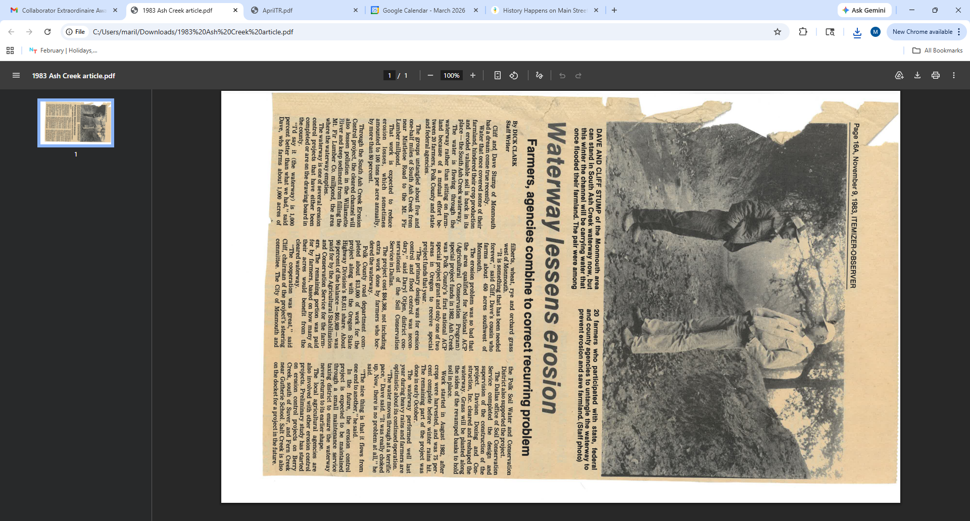

Oath of Office

I, _______________________________, do solemnly swear, that I will support the Constitution of the United States, the Constitution of the State of Oregon, the laws thereof, and the policies of the Ash Creek Water Control District, and that I will faithfully discharge the duties of Director according to the best of my ability, so help me God.

Done, this ______ day of ________________________

__________________________________________

Attest:

________________________________________
Name

________________________________________
Title

