Ash Creek Water Control District, AGENDA
Board Meeting – February 5, 2026
Board meeting begins at 6:30 PM
The meeting is an in-person event at Indy Commons with a Zoom option.
Zoom will also be available: https://us06web.zoom.us/j/82158510794?pwd=zBEajDFo31FeaehdbuRWLOkQoafd5S.1

- Call to Order
- Roll Call

Brooke Getty
Madeline Fisher
Tom Wilson
Molly Barbano
Lauren Zatkos
Ed Matteo
Todd Whitaker
Amy Albrich
Guests?
(Marilyn Morton, recording)

- Minutes of January meeting (attached)
- Audience Comments
- Director Comments
- Reports
- Finance: Monthly Report
- Phone: Monthly Report
- Nutria: Monthly Report
- Precipitation: Monthly Report
- Engineer’s Report
- Education Grants
- Unfinished Business
Work session for 10-year strategic plan/Policies and Procedures manual
Secretary of State registration follow-up
- New Business
- Queries – Matt Brown, Mahonia NW, and City of Monmouth, flood plane feasibilities
10. Adjournment & next meeting

Documents following include:
Minutes from January meeting

Financial recap of latest information available from institutions.

Board of Directors, Positions & Terms

Links for communications from SDAO

Correspondence from Tom:
The main thing that I had to discuss is two recent requests for data from our Hydraulic Model.
- A planned development along the south fork of Ash Creek east of 13th street, and
- A contemplated project to raise Riddell Road at the middle fork of Ash Creek.
I am comfortable sharing the surveyed cross sections for both of those reaches, with a disclaimer regarding the age of the survey information. I don't think I feel comfortable sharing our predicted flood elevations, because those were based on different parameters than what is required for land use planning.
Noteably, the District Hydraulic Modelling effort sought to estimate the "actual" base flood elevation (BFE), which meant we started by matching the FEMA BFE of the Willamette at the confluence and modelled continuously upstream to the upper limit of our study area (Dallas area). If we had started the South Fork model at let's say, F Street, we would have had to match the FEMA BFE at F Street and proceed upstream, yielding a potentially different BFE at any point.
Secondly, the channel roughness that was estimated when our model was created may be different than the channel roughness that exists today, since channel roughness is determined by the level of vegetation and obstructions.

So, to make sure that we are not influencing the BFE calculated by any particular study, we typically provide only the survey data from the cross sections that were taken at certain locations. However, since it has been 25 years and some minor changes may have occurred to elevations, I would put a disclaimer to that effect when sharing the data.
You have several options at this point:
- Deny the request on the basis of age and accuracy of our data,
- Authorize the release of data (it is public information), with a disclaimer about its age and accuracy,
- Save this item for discussion at the next Board meeting.
If you choose #3, I may need a white-board at the next meeting to illustrate this concept.
Let me know if you have any questions.

Tom Wilson via fwd.oxsus-vadesecure.net

to distsec, corporationdivision.sos@sos.oregon.gov

Talked to someone on the phone about our requirements to file with your organization. As a special district under ORS 553 we are considered a local government agency and have a Municipal customer number001185MUNI and tax id code 930918730

I need some documentation to let our bank and others know we are not required to file with you. Thanks!

Ash Creek Water Control District, MINUTES
Board Meeting – January 8, 2026, 6:30 PM at Indy Commons with a Zoom option.
- Call to Order: President/Treasurer Tom Wilson declared a quorum and opened the meeting at 6:34 PM.
- Roll Call. Board members present or online included: Brooke Getty, Molly Barbano, Madeline Fisher, Tom Wilson, Lauren Zatkos, and Amy Albrich. Excused board member(s): Ed Matteo. Guests: Gerald Fisher, Independence Public Works Director., Elizabeth Sagmiller, contractor. Marilyn Morton recording.
- Approval of Minutes of December 4, 2025: Correction made – minutes should have read “Elizabeth Sagmiller” (not Sagmeyer). Amy moved to approve the corrected minutes of 12-4-25, Lauren 2nd, motion passed unanimously.
- Audience Comments: none
- Director Comments: none
- Mancil Russell (retired from board) made comments
- Madeline: Kevin Porter is interested in stormwater quality assessment of Ash Creek, and should be contacting ACWCD in January.
- At Monmouth Library on Jan 17, 11 AM, there will be a talk on Streamside Management
- Brian Dutton, biologist at WOU will be coming to future meetings about invasive species.
- Tom reviewed document discoveries from 2023 zip drive. ACWCD has a good baseline survey. He is going to a slide show presentation at WOU and will share information which may assist in the development of the 10 year plan.
- Lauren: Oregon Dept of State Lands fees were raised. This will impact water/wetland mapping groups
- Reports
- Finance: Monthly Report. Tom reviewed the financial report that was delivered in the agenda packet for this meeting. Other notes:
- $266 due to SDAO
- $600 due for streamlining PDFs (program working)
- $1,320/year for website hosting
- $500 ACWCD gift card purchase reimbursed to Tom
- Phone: Monthly Report: Molly reported no calls. Lauren will take the phone for the next month.
- Nutria, Monthly Report: Tom said there was a nutria sighting in Mt. Fir Inspiration Garden.
- Precipitation: Monthly Report from Madeline
December 2025, 8.65”
December 2024, 8.5”
December 2023, 7.76”
December 2022, 7.25”
December 2021, 11.01”
- Engineer’s Report: None
- Education Grants: Brooke is in contact with Ash Creek Elementary School re. latest grant. She has offered a presentation to students (est. 75) by the ACWCD Board, which was agreeable to board
- Information presented by meeting guests:
Mark Landau, Operations Manager for Monmouth Public Works, discussed management of sewer/streets in storms. He also described work done by a RARE student with MPW who was working on a traveling information cart for sharing, and long-term tree planting (3,607 trees and shrubs planted).
Kevin Porter is District Manager for Polk Soil & Water Conservation District. He serves the whole county, oven overlapping with ACWCD coverage. Current project is working on the flow of mercury in the Salt Creek & Ash Creek Swale area.
Christine & Nate Tisdall are interested in water regulation and discharge and in drinking water systems and environmental health in Polk County.
- Unfinished Business
- Next two meetings will be work sessions covering 10 year Strategic Plan. Tom handed out to all, reminding that there is a “read and understood” statement that board members must sign. Please focus on Section 5, “Mission/Goals/Objectives” for future meetings.
- Mancil, Gerald Fisher & Elizabeth Sagmiller discussed what’s happened in the past with work within the district.
- Elizabeth Sagmiller, E & S Consulting, worked as resource for local government for 25 years, focused on TMDL for the Willamette Sub Basin in 2025, and on lowering water temperatures for fish habitat. She oversaw replanting and protection of riparian areas, and completed a study of which areas along Ash Creek can be benefitted by restoration. Discussion continued about work done and work that could be done based on current priorities.
- Gerald was asked how ACWCD could help Independence? He said a new masterplan was coming shortly which will delineate high, medium and low priorities for a 20-year Master Plan update. He stressed that the ACWCD area will be getting more security from DEQ and there could be more reporting requirements. He described the evolution of the area planning processes.
- Gerald also said the city budgets yearly for ACWCD assistance, but has little control over private properties. DEQ would like more enforcement/influence opportunities.
- The storm water master plan is due in Fall 2026. SDCs rates and updates follow, it will be a full public process.
- Marilyn provided a registration form for Secretary of State to Tom.
- Trash Can signage replacement: Work is done.
- Budget Committee: Tom reminded the board that a budget committee will be forming, consisting of an equal number of board members and community members
- New Business, Miscellaneous Business/Information Items (many covered in old business, see above.
- Adjournment: Tom called the meeting adjourned at 7:47 PM. The next meeting will be February 5, 2026, 6:30 PM, at Indy Commons.

Financial Reports for Ash Creek Water Control District beginning 1-1-2025
Pioneer Trust Bank
 | Date | Credit | Debit | Running Balance
Beginning Balance | 1/1/2025 |  |  | $ 5,950.93
Ascension Accounting | 1/2/2025 |  | $ 249.67 | $ 5,701.26
Ascension Accounting | 1/3/2025 |  | $ 54.00 | $ 5,647.26
2339, Marilyn Morton | 1/8/2025 |  | $ 200.00 | $ 5,447.26
2338, Streaming Annual | 1/10/2025 |  | $ 1,260.00 | $ 4,187.26
2340, SDIS Annual | 1/10/2025 |  | $ 2,780.00 | $ 1,407.26
Xfer from LGIP | 1/14/2025 | $ 5,000.00 |  | $ 6,407.26
Interest | 1/31/2025 | $ 3.63 |  | $ 6,410.89
ACH, Ascension Accounting | 2/5/2025 |  | $ 161.33 | $ 6,249.56
2341, Marilyn Morton fee | 2/6/2025 |  | $ 200.00 | $ 6,049.56
2342, Indy Commons space rental | 2/6/2025 |  | $ 30.00 | $ 6,019.56
2343, Or Sec'ty State Business renew | 2/24/2025 |  | $ 40.00 | $ 5,979.56
Interest earned | 2/28/2025 | $ 3.06 |  | $ 5,982.62
ACH, Ascension Accounting 10017 | 3/4/2025 |  | $ 465.23 | $ 5,517.39
ACH, Ascension Accounting 10038 | 3/4/2025 |  | $ 54.00 | $ 5,463.39
2344, Marilyn Morton fee | 3/5/2025 |  | $ 200.00 | $ 5,263.39
2345, Indy Commons space rental | 3/6/2025 |  | $ 30.00 | $ 5,233.39
Interest earned | 3/31/2025 | $ 2.99 |  | $ 5,236.38
2346, LWC: GW Restoration | 3/31/2025 |  | $ 680.13 | $ 4,556.25
ACH Ascension Accounting 10115 | 3/31/2025 |  | $ 90.00 | $ 4,466.25
2347, Marilyn Morton fee | 4/3/2025 |  | $ 200.00 | $ 4,266.25
2348, Indy Commons (Board mtg) | 4/3/2025 |  | $ 40.00 | $ 4,226.25
ACH Ascention Accounting 10192 | 4/3/2025 |  | $ 54.00 | $ 4,172.25
2349, LWC, Ash Creek Contract | 4/8/2025 |  | $ 14,593.27 | $ (10,421.02)
LGIP ACH Redemption | 4/9/2025 | $ 15,000.00 |  | $ 4,578.98
Interest Earned | 4/30/2025 | $ 2.50 |  | $ 4,581.48
2350, Marilyn Morton fee | 5/1/2025 |  | $ 200.00 | $ 4,381.48
2351, Indy Commons space rental | 5/1/2025 |  | $ 20.00 | $ 4,361.48
2352, Affordable Storage rental | 5/1/2025 |  | $ 605.00 | $ 3,756.48
2353, Tom Wilson, email reimb. | 5/20/2025 |  | $ 559.90 | $ 3,196.58
2354, LWC AC Reneg Contract | 5/28/2025 |  | $ 51,174.53 | $ (47,977.95)
LGIP ACH Redemption | 5/31/2025 | $ 55,000.00 |  | $ 7,022.05
ACH, Ascension Accounting | 5/28/2025 |  | $ 102.75 | $ 6,919.30
2355, Tom Wilson email reimb. | 5/29/2025 |  | $ 64.99 | $ 6,854.31
2356, Marilyn Morton fee | 6/5/2025 |  | $ 200.00 | $ 6,654.31
2357, Independence Nursery/Water Grd | 6/5/2025 |  | $ 600.00 | $ 6,054.31
Interest earned | 5/30/2025 | $ 6.36 |  | $ 6,060.67
ACH, Ascension Accounting | 6/2/2025 |  | $ 54.00 | $ 6,006.67
Ascension Accounting | 6/17/2025 |  | $ 54.00 | $ 5,952.67
Interest earned | 6/30/2025 | $ 12.64 |  | $ 5,965.31
USPS Box 81 | 7/1/2025 |  | $ 210.00 | $ 5,755.31
Polk County Clerk Election Fee | 7/1/2025 |  | $ 4,936.85 | $ 818.46
SAIF Insurance (annual) | 7/1/2025 |  | $ 306.63 | $ 511.83
CNA Surety (annual) | 7/1/2025 |  | $ 500.00 | $ 11.83
LGIP Reimbursemsent | 7/14/2025 | $ 10,000.00 |  | $ 10,011.83
Ascension Accounting | 7/5/2025 |  | $ 141.50 | $ 9,870.33
Ascension Accounting | 7/25/2025 |  | $ 135.00 | $ 9,735.33
Interest | 7/31/2025 | $ 5.33 |  | $ 9,740.66
Roam Forestry | 8/7/2025 |  | $ 7,306.41 | $ 2,434.25
Marilyn Morton | 8/7/2025 |  | $ 200.00 | $ 2,234.25
LGIP Transfer | 8/7/2025 | $ 5,000.00 |  | $ 7,234.25
Ash Creek Elementary Ed. Grant | 8/7/2025 |  | $ 835.00 | $ 6,399.25
Talmadge Middle School Ed. Grant | 8/7/2025 |  | $ 1,000.00 | $ 5,399.25
Ascension Accounting | 8/1/2025 |  | $ 54.00 | $ 5,345.25
Ascension Accounting (2) | 8/25/2025 |  | $ 176.90 | $ 5,168.35
Interest | 8/25/2025 | $ 4.55 |  | $ 5,172.90
LGIP Transfer | 8/30/2025 | $ 10,000.00 |  | $ 15,172.90
Marilyn Morton | 9/4/2025 |  | $ 200.00 | $ 14,972.90
Indy Commons, meeting place | 9/4/2025 |  | $ 60.00 | $ 14,912.90
LWC Reneg. Contract | 9/4/2025 |  | $ 7,870.40 | $ 7,042.50
Marilyn Morton | 10/9/2025 |  | $ 200.00 | $ 6,842.50
Indy Commons, meeting place | 10/9/2025 |  | $ 30.00 | $ 6,812.50
New Checks (delux) | 9/16/2025 |  | $ 33.97 | $ 6,778.53
Interest | 9/30/2025 | $ 4.58 |  | $ 6,783.11
Ascension Accounting (2) | 10/3/2025 |  | $ 78.50 | $ 6,704.61
Marilyn Morton, Audit Reimb. | 11/6/2025 |  | $ 40.00 | $ 6,664.61
Marilyn Morton (Dec Pay) | 11/6/2025 |  | $ 200.00 | $ 6,464.61
Indy Commons, meeting place | 11/6/2025 |  | $ 40.00 | $ 6,424.61
Luckiamute WC Reveg. Project | 11/6/2025 |  | $ 19,367.40 | $ (12,942.79)
Ash Creek Elementary Ed. Grant | 11/6/2025 |  | $ 981.00 | $ (13,923.79)
SAIF Refund | 10/22/2025 | $ 28.00 |  | $ (13,895.79)
Interest | 10/31/2025 | $ 3.22 |  | $ (13,892.57)
LGIP Redemption | 11/10/2025 | $ 20,000.00 |  | $ 6,107.43
Ascension Accounting | 11/7/2025 |  | $ 58.50 | $ 6,048.93
Interest | 11/29/2025 | $ 10.49 |  | $ 6,059.42
Marilyn Morton | 12/8/2025 |  | $ 200.00 | $ 5,859.42
Indy Commons, meeting place | 12/8/2025 |  | $ 30.00 | $ 5,829.42
Ascension Accounting (4) | 12/8/2025 |  | $ 142.40 | $ 5,687.02
Gift Card Purchase (reimb Tom Wilson) | 12/8/2025 |  | $ 500.00 | $ 5,187.02
Interest | 12/31/2025 | $ 1.85 |  | $ 5,188.87
SDAO | 1/1/2026 |  | $ 266.00 | $ 4,922.87
Streamline - Doc Access | 1/1/2026 |  | $ 600.00 | $ 4,322.87
Streamline - Website | 1/1/2026 |  | $ 1,320.00 | $ 3,002.87
LGIP Redemption | 1/5/2026 | $ 10,000.00 |  | $ 13,002.87
Marilyn Morton (Jan Pay) | 1/8/2026 |  | $ 200.00 | $ 12,802.87

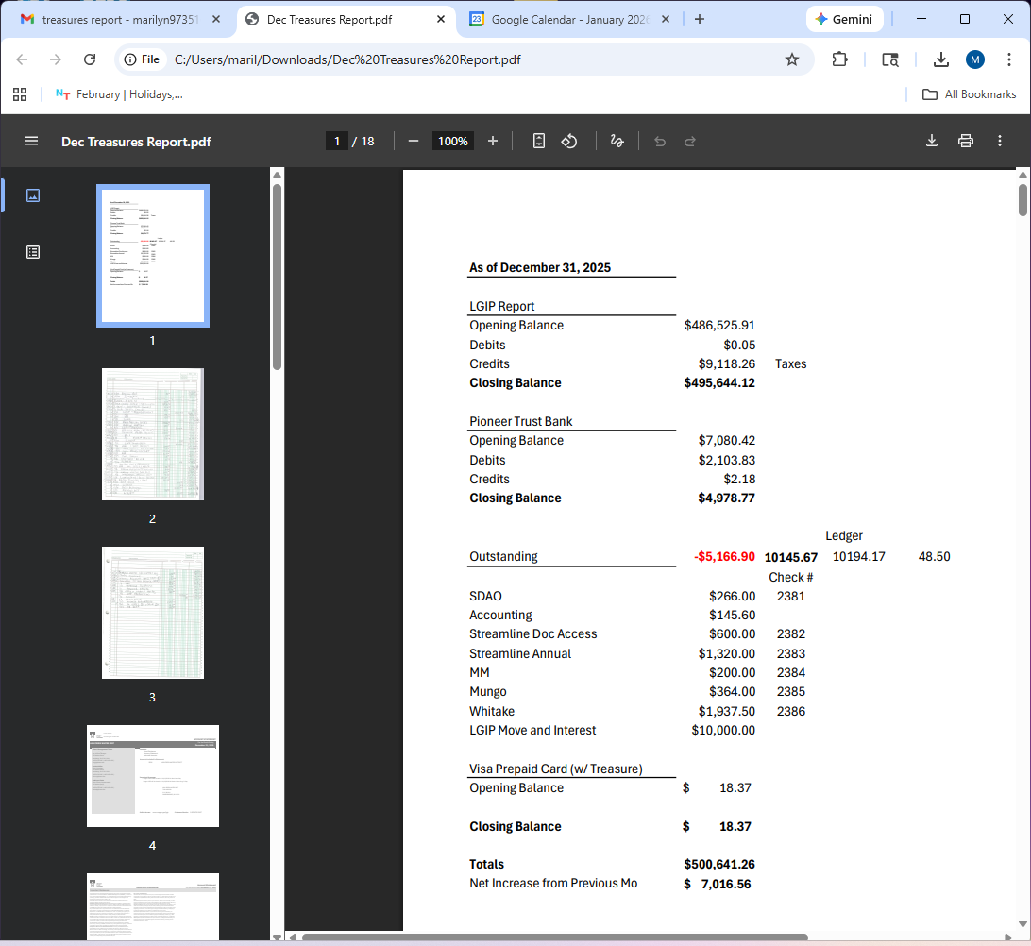

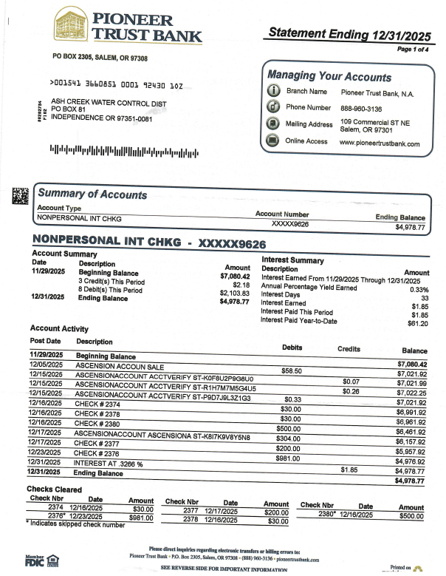
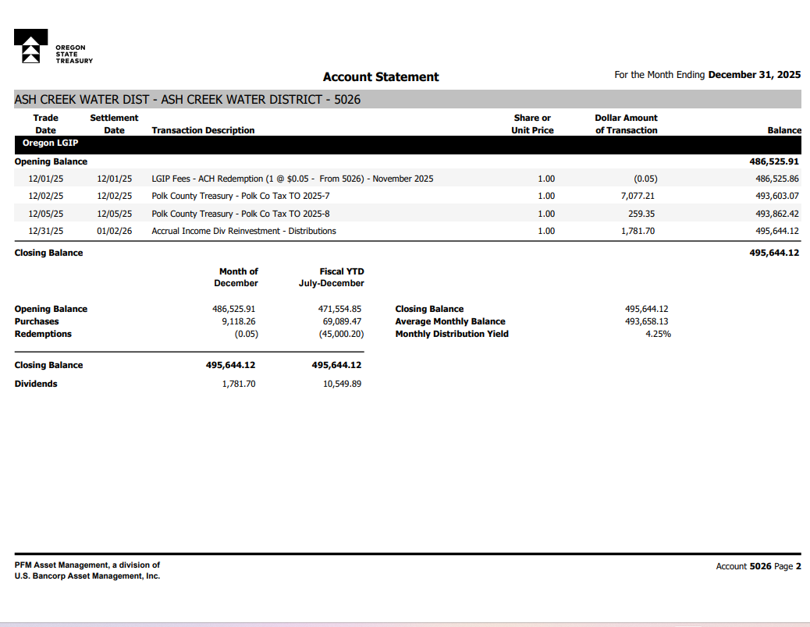

Board of Directors, Positions & Terms after May 20 election

Mailing Address & Phone Number for all Directors:
PO Box 81, Independence, OR 97351, 503 779-9869

Director #1
Tom Wilson, President & Treasurer
Term: 2027
Email: director1@ashcreekwcd.com

Director #2
Vacant
Next election: 2027
Email: director2@ashcreekwcd.com

Director #3
Madeline Fisher
Term expires: 2029
Email: director3@ashcreekwcd.com

Director #4
Molly Barbano
Term expires: 2028
Email: director4@ashcreekwcd.com

Director #5
Brooke Getty
Term expires: 2028
Email: director5@ashcreekwcd.com

Director #6
Ed Matteo, Vice President
Term expires: 2027
Email: director6@ashcreekwcd.com

Director #7
Lauren Zatkos
Term expires: 2029
Email: director7@ashcreekwcd.com

Director #8:
Amy Albrich
Term expires: 2027
Email:
Director8@ashcreekwcd.com

Director #9
Position remains vacant
Term expires: 2029
Email: director9@ashcreekwcd.com

Content/Links for electronic correspondence:
From SDAO:
https://www.magnetmail.net/actions/email_web_version.cfm?ep=aiG7TXw8p6eAbFY-OXtJeeh-YEJi5KifS4hIjg748XrtQhD3K8lAKeeK3G7gZ-W-4iZRRjzaHtGe2qdJ7Rw_I0km-d6SefaGGgua5__pvd3yb2Lq-ZXhCXyI_YLsp08f
https://www.magnetmail.net/actions/email_web_version.cfm?ep=aiG7TXw8p6eAbFY-OXtJeeh-YEJi5KifS4hIjg748XoI_HlRM5EHyXEU4o1iWYQMgOK_ZOzenI3dkcGEDsg17p1351X7BHk9T_EluVtD3F5AVrXCxhVsJDHt6ixEZ_pA
https://www.magnetmail.net/actions/email_web_version.cfm?ep=aiG7TXw8p6eAbFY-OXtJeeh-YEJi5KifS4hIjg748XoNeFw2rVfqK8Yx9vyMuGKCV2rYQm_uB0l_ig0pqEIwCYJI_anbcOpTht50vgPInfUE3ZtuihF33ldw-LmfsvsA
https://www.magnetmail.net/actions/email_web_version.cfm?ep=aiG7TXw8p6eAbFY-OXtJeeh-YEJi5KifS4hIjg748XoaseowgKZYPkEU9I-0i_B1xRTCSI7dUKHQydabka9oDgpqFQyXfdH_ASdtQK1AhFGZUnx7wJ2WLA1kCeatqIQm
https://www.magnetmail.net/actions/email_web_version.cfm?ep=aiG7TXw8p6eAbFY-OXtJeeh-YEJi5KifS4hIjg748XoLPEOXsuDhlFostp7EG23cSL-v5aMzIhCtU34dBnzWO7_-fXcol2rOWVoNDHYrhNsFkLaQfaGtqD9CQA1QEVtW

